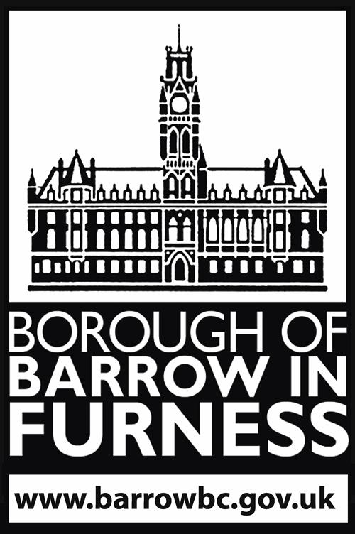

Licensing Act 2003 –

Guidance on making a representation

Purpose
The purpose of this guidance is to offer assistance to local residents, or any other party, wishing to make representations about licensing applications, e.g. applications for new premises licences or applications to vary existing premises licences and club premises certificates made under the Licensing Act 2003.
This guidance explains who is entitled to make representations and how such representations should be made. It also explains the process which follows once representations have been received by the Council.

Licensing Act 2003
The Licensing Authority (Barrow Borough Council) issues premises licences and club premises certificates which allow businesses and recognised clubs to carry out the following licensable activities:
• Sale/supply of alcohol
• The provision of regulated entertainment
• The provision of late night refreshment between 11pm and 5am.
This affects pubs, bars, restaurants, supermarkets, off licences, cinemas, theatres, community premises and late night takeaways to name just a few.
The Act requires applicants for licences to stipulate how they will promote the licensing objectives of:-
• Protection of children from harm
• Prevention of public nuisance.
• Prevention of crime and disorder
• Public safety
These licensing objectives have equal weight and form the basis of how the Act works.

Application made under the Licensing Act 2003
A premises licence can authorise one or more licensable activities. Some premises, such as takeaways, will just have late night refreshment while other venues such as hotels and night clubs may have a combination of all licensable activities.
At any time the holder of a premises licence or club premises certificate can make an application to the Licensing Authority to vary their licence. These variation applications as well as brand new premises licence applications must be advertised so local residents can object to the Council.

Advertising of applications
A blue notice will advertise an application for a new licence or a variation to an existing licence. The notice must be prominently displayed on or near the premises, in a place that is accessible by the public.
The notice will provide a final date for representations as well as brief details of the application.
For full variations and new premises licence applications applicants must also place a notice about their application in a local newspaper. This notice will appear within 10 days of the applicant making their application to the Council.
The council also publishes all applications received on our website. See http://licensing.barrowbc.gov.uk/LicReg/Licensing/Default/Premises

Criteria for making a representation
Your representation must be relevant and based on the likely effect the granting of the application will have on the promotion of the four licensing objectives.
For example, if you are concerned the granting of a variation will lead to an increase in crime and disorder in the area of the premises, this is a relevant representation.
However, if you are concerned that the granting of longer hours at the premises will lower house prices in the area; this is not a relevant representation and cannot be considered by the Licensing Authority.
The Licensing Authority will also not consider representations that are frivolous or vexatious, e.g. a frivolous representation is one that does not have a serious purpose or is not serious in its nature, whilst a vexatious representation is one that is made purely to cause annoyance to the applicant.

The Licensing Authority will not accept anonymous representations, the person making the representations are required to include their name and address.

Relevant representations must be in writing and submitted to the Licensing Authority, this does include emails. Your representation must reach us within the 28 day notice period and can be emailed to commercial@barrowbc.gov.uk or sent to the Licensing Team, Public Protection Services, Barrow Town Hall, Duke Street, Barrow in Furness, Cumbria, LA14 2LD.

You may wish to use the form at the end of this guidance to make your representation.

Late representations will not be considered. If you are unsure when the application was made, you can email the Council.
A member of the licensing team will initially check your representation to ensure that your comments relate to one or more of the four licensing objectives. Assuming that your representation fulfils the criteria, it will be copied and sent to the applicant, along with any other representations received.
It is important that the applicant is provided with the opportunity to address the comments raised in your representation.
In addition, a copy of your representation, including your personal details will be included in the committee papers all of which are public documents. A copy of these papers will be published on the Council’s website.
If you do not want your personal details to be released then you will be unable to make a personal representation unless there are exceptional circumstances. For example if you believe that you may suffer reprisals if your personal details are released you can contact the council to discuss this. It may in some cases be possible to exclude your personal details if the circumstances warrant it.

Petitions
The Licensing Authority may accept petitions, but there are some important factors to consider before organising a petition:
- The petition must relate to one or more of the licensing objectives to be a valid representation
- Each page of the petition should contain information as to the purpose of the petition so that all persons know what they are signing.
- Full names and addresses must be supplied and be legible
- All signatories must be made aware that a copy of the petition will be supplied to the applicant and a copy will be contained within the committee papers, so their personal details will become public knowledge. The instigator of the petition should make any signatories aware of this.
- We ask that the instigator of the petition is identified as a central point of contact. We may need to make contact in order to verify certain matters and if we are unable to do this it could invalidate the petition
- It is expected that the instigator will represent the signatories at the hearing and to speak for them

Hearings
If relevant representations are made the application will shall be referred for a hearing of a Licensing Sub-Committee.
The Licensing Sub-Committee is made up of three Councillors selected from the full Licensing Committee but Councillors whose ward the premises is located in will not be eligible to sit on the Sub-Committee.
All parties (the applicant and any objectors), will receive a Notice of Hearing. The Notice will set out the date, time and location and explains the procedure to be followed at the hearing. This notice is usually sent out at least ten days before the hearing.
All parties will be able to address the Sub-Committee.
Please note that whilst this is a public hearing only those who have made their identity known through submission of a valid representation may address the Committee in person.
Even if you are unable to attend the hearing the Sub-Committee will still consider your written representation.
In making decisions the Sub-Committee will take into account all of the written and verbal evidence before them. They also have a duty to take into account the licensing objectives set out in the Act, The Council's Statement of Licensing Policy and guidance given by the Secretary of State.
The Sub-Committee will announce their decision at the hearing, and written confirmation will be distributed to all parties following the hearing.
If any party is aggrieved by the decision, then there is a right of Appeal to the Magistrates Court.

Representation Form

Your Name/Company Name/Name of Body you represent.
Address

Contact telephone number
Email address

Name of the premises you are making a representation about.
Address of the premises you are making a representation about.

Your representation must relate to one of the four Licensing Objectives. Please state yes or no. | Yes  No | Please detail the evidence supporting your representation. Or the reason for your representation. Please use separate sheets if necessary
Protection of children from harm

Prevention of public nuisance

Prevention of crime and disorder

Public Safety

Suggested conditions that could be added to the licence to remedy your representation or other suggestions you would like the Licensing Sub Committee to take into account.

I declare that I have read the attached guidance and understand my representation and personal details will be shared with the applicant and will be part of the public papers at any Sub-Committee hearing.
Signed: | Dated:

Please return this form along with any additional sheets to: The Licensing Manager, Public Protection Services, Town Hall, Duke Street. Barrow in Furness, Cumbria LA14 2LD or email commercial@barrowbc.gov.uk. This form must be returned within the statutory consultation period. Please check with the Licensing Authority. Telephone: 01229 876543.

