
HACKNEY CARRIAGE AND PRIVATE HIRE VEHICLE ACCIDENT REPORT FORM

Section 50(3) of the Local Government (Miscellaneous Provisions) Act 1976 requires the proprietor of a hackney carriage or private hire vehicle to report an accident to the licensing authority within 72 hours. Accidents must still be reported whether the vehicle was carrying passengers at the time or not.

All parts of this form must be completed and returned to commercial@barrowbc.gov.uk, or via post to Barrow Town Hall.

Failure to report any accident may result in prosecution or action taken on a driver/vehicle licence.

VEHICLE DETAILS

PRIVATE HIRE HACKNEY CARRIAGE

Vehicle licence plate number (eg. HV123/PV123)
Registration number
Vehicle make & model
Vehicle colour
Name of insurance company
Is CCTV/DASHCAM fitted to the vehicle? | YES / NO  DASHCAM / CCTV / BOTH
Name of driver at time of accident
Badge number at time of accident

PROPRIETOR DETAILS

Proprietor name
Proprietor address & postcode
Telephone number
Email address
Private hire operator working for (if any)

ACCIDENT DETAILS

Date of accident |  | Time of accident (24 hour clock)
Place of accident
Description of the accident
Was the accident reported to the police? | YES / NO
Were the driver or passengers injured? If YES, please give details. | YES / NO
Were any other vehicles involved? If YES, please complete the next section. | YES / NO

THIRD PARTY VEHICLE DETAILS (if applicable)

Registration number of vehicle |  | Vehicle make
Vehicle model |  | Vehicle colour
Name of insurance company
Driver name & address
Were the driver or passengers injured in the third party vehicle? If YES, please give details. | YES / NO

VEHICLE DAMAGE

Indicate clearly on the diagram, the position and type of damage caused to your vehicle as a result of this accident. Indicate S for scratch, D for dent, M for missing parts and P for pre-existing.

Please also attach any photographs of the damage.

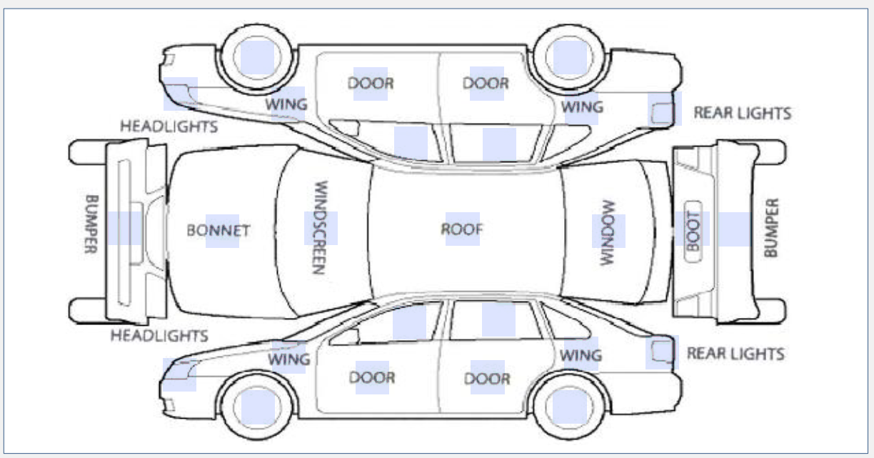

Please use this section for any additional notes or information

DECLARATION

I confirm that the details provided above are correct and I will notify the Council when any repairs to the vehicle have been carried out. I confirm that the vehicle will not be used for hire or reward until the Council has assessed the damage.

I understand that this vehicle may be suspended by the Council until it has been deemed fit for use.

I understand that it is a criminal offence to make a false statement or omit any material particular from this document.

SIGNED
Signature | Print Name | Date

DATA PROTECTION: Personal information provided in an application form and during the period of any subsequent Licence is normally held for a period of six years from the expiry of the last consecutive Licence held. It will be used primarily for the purpose of the licensing function concerned although it may also be used for data matching purposes across various licensing functions. Personal information held for licensing purposes will be held and used in accordance with the requirements of the Data Protection Act 2018 and General Data Protection Regulations. To assist the Council in the prevention and detection of fraud so that it can protect the public funds it administers the Council may use information provided for licensing purposes within this Authority for data matching purposes. It may also data match information provided for licensing purposes with other public bodies that regulate, administer or are in receipt of public funds for the purposes of the prevention and detection of fraud. If you do have any queries regarding any Data Protection, please contact the responsible officer.

FREEDOM OF INFORMATION: Information held by the Council may need to be disclosed in response to a request for it within the terms of the Freedom of the Information Act 2000. This information excludes that which is in any other way already in the public domain.

INFORMATION SHARING: The Department for Environment Food & Rural Affairs (Defra), which is a government department, is collecting data from licensing authorities in England and Wales for all vehicles licensed as a taxi or private hire vehicle. Under the Air Quality (Taxi and Private Hire Vehicles Database) (England and Wales) Regulations 2019 (SI 2019 No. 885) it is a legal obligation for licensing authorities to provide Defra with the following data:
- Vehicle registration mark of the vehicle
- Date from which the vehicle’s licence has effect
- Date on which the vehicle’s licence is due to expire
- A statement as to whether the vehicle is a taxi or private hire vehicle
- Other information the licensing authority holds in relation to the vehicle that may be relevant for the purposes of ensuring the accurate identification of vehicles, having had regard to any guidance issued by the Secretary of State. That is:
  - Licence plate number
  - An indication as to whether it is a wheelchair accessible vehicle.

The processing of the information (under Article 6.1 (c) of the GDPR) is for the purpose of ensuring that Clean Air Zone (CAZ) charging is applied correctly in adherence with the Clean Air Zone Framework. Licensing authorities hold information on taxis and PHVs only within their own area so are not able to clearly identify and charge a taxi/PHV entering or moving around their charging CAZ which has been licensed by another authority.
Defra may, under contracts or similar agreements, use third party organisations to process the data provided on its behalf. This will include the creation and provision of the Taxi and PHV Database to support local authorities’ ability to charge in relation to charging Clean Air Zones. These organisations will not be able to use the data for any other purpose and must meet the requirements of data protection legislation and government’s security standards.

