BOROUGH OF BARROW IN FURNESS

OVERVIEW AND SCRUTINY COMMITTEE

Meeting, Thursday, 9th February, 2017
at 2.00 p.m.

PRESENT:- Councillors Heath (Chairman), Cassidy (Vice-Chairman), Gill, Husband, McLeavy, Preston, L. Roberts, C. Thomson and Williams.

Officers Present:- John Penfold (Corporate Support Manager), Brooke Parsons (Corporate Support Assistant), Paula Westwood (Democratic Services Officer - Member Support) and Katie Pepper (Democratic and Electoral Services Apprentice).

31 – Apologies for Absence

Apologies for absence were received from Councillors Proffitt, M. A. Thomson and Wall.

32 – Minutes

The Minutes of the meeting held on 1st December, 2016 were taken as read and confirmed.

33 – Minutes of the Barrow Market Liaison Committee

The Minutes of the Barrow Market Liaison Committee meeting held on 14th July, 2016 had been submitted for information and had been duly noted.

34 – Friends of Barrow Cemetery

The Corporate Support Assistant advised that at a meeting of this Committee in October 2015 it had been agreed that a Friends of Barrow Cemetery Group be established. She advised the Committee that she had contacted the National Federation of Cemetery Friends to enrol the Council as associate members.

The National Federation of Cemetery Friends represented groups of volunteers interested in conserving cemeteries large and small. The Cemetery Friends gave their time clearing and maintaining areas, often working with local ecology groups to maintain a balance between wildlife and heritage and also provided guided walks, open days and special events as well as working on projects with English Heritage and other organisations. She advised the Committee that the National Federation of Cemetery Friends had requested an annual subscription payment for 2017 of £20.00 and requested the Committee’s endorsement to continue with membership.

RESOLVED:- To agree to continue with the membership of the National Federation of Cemetery Friends and pay the annual subscription fee of £20.00 for 2017.

35 – Friends of the Town Hall

The Corporate Support Manager reported that a number of Tours of the Town Hall had taken place via the Friends of the Town Hall Group, conducted by the Senior Steward; one of which had been featured in the local press. He advised that the Senior Steward continued to monitor tour requests and he had suggested that more publicity was required.

It was moved by Councillor Cassidy and seconded by Councillor Heath to speak to the Press Officer present following the meeting.

It had also been noted that Councillor Cassidy had agreed to write to the Executive Director of the Council regarding accessing Heritage Lottery Funding.

RESOLVED:- (i) To note that the Vice-Chairman of the Committee would speak to the press regarding publicity of the Town Hall Tours; and

(ii) To note that the Vice-Chairman would write to the Executive Director regarding supporting Heritage Lottery Funding for the Town Hall.

36 – Egerton Court

An update on the progress of the Egerton Court scrutiny review had been circulated by Councillor Cassidy as follows:-

It was noted that a Multi-Agency Streetsafe operation had been delivered in Egerton Court mid-January 2017. This had been a great success and had provided the Police and other service providers with intelligence and information that could be used to improve the quality of life for residents in and around the area. The Police had collated and reviewed the data and were sharing specific resident concerns with partner organisations. Related actions would be delivered over the coming weeks and months.

In respect of the Waste Management arrangements at Egerton Court it was noted that the Streetcare Team had reviewed the arrangements for refuse and recycling collections in the area and would be providing eight new 240 litre bins per block, four for refuse and four for recycling. The bins would be locked to prevent misuse and anti-social behaviour with the Waste Collection Contractor holding the key. It was noted that Cumbria County Council had secured £3,000 from the Community Waste Prevention Fund to help finance the purchase of the bins and that Barrow Borough Council would be leafleting the area to ensure residents had been made aware of the change in arrangements.

In respect of parking it was noted that Cumbria County Council had delivered a great deal of positive activity across the wider Barrow Island ward to tackle illegal and nuisance parking. Signs and parking lines on the highway had been refreshed, further enforcement resource had been drafted into the area in the short-term and formal consultation on the new Traffic Regulation Order had been agreed.

In respect of letting properties and streetscene, Council Officers had worked hard to collate a definitive list of leaseholders and freeholders for the area and were actively pursuing more contact details for the management of some of the lettings. The proposal for Selective Licensing would be considered by the Multi-Agency Group and it was likely to be determined by levels of anti-social behaviour reported in the area. A Landlord’s Forum had also been suggested and that was being considered. The Corporate Support Manager advised the Committee that Selective Licensing of Private Landlords in Egerton Court had been considered by the Executive Committee in May 2016 and it had subsequently been agreed by Council in July 2016 to agree in principle to the designation of Egerton Court as an area where Selective Licensing would be in force and to authorise the Assistant Director of Regeneration and Built Environment to take all the necessary to steps to implement that designation and appoint a temporary member of staff for a period of up to 18 months to introduce Selective Licensing in that area.

It was moved by Councillor Heath and seconded by Councillor Cassidy that the Selective Licensing guide be made available to all Members.

RESOLVED:- (i) To note the update regarding Egerton Court; and

(ii) To agree that a guide for Selective Licensing be made available to all Members of the Council.

37 – Performance Management

The Corporate Support Manager advised that at the meeting of this Committee on 1st December, 2016, performance information relating to the speed of processing claims for Housing Benefit and Council Tax Support had been presented as part of the quarterly update. At that time Members had requested further information relating to the quality of processing claims which had been presented in the report as follows:-

Indicator | Quarter 3 | Target
Average time to process new housing benefit claims | 13.8 days | 18 days
Average time to process new council tax support claims | 14 days | 18 days
Average time to process housing benefit changes of circumstances | 5.5 days | 7 days
Average time to process council tax support changes of circumstances | 4.3 days | 6 days
Percentage of new housing benefit claims decided within 14 days of receiving all information | 100% | 99%
Reconsiderations and appeals processed and notified within 4 weeks (HB & CTS*) | 80.5% | 80%
Percentage of financial errors identified from the daily 10% random sample (HB & CTS*) | 5.4% | 8%
Percentage of non-financial errors identified from the daily 10% random sample (HB & CTS*) | 6.8% | 8%
*HB & CTS Housing Benefit and Council Tax Support claims combined

Members had been requested to note that the targets were set annually with the Strategic Partnership Board.

RESOLVED:- To note the information.

38 – Core Spending Power

The Corporate Support Manager advised that at the meeting of this Committee on 1st December, 2016, the budget assumptions had been presented. At that time Members had requested further information relating to the Core Spending Power per dwelling.

The Core Spending Power was calculated by the Government and was published with the financial settlement each year. The components of the Core Spending Power calculation had varied over time and had been named Revenue Spending Power initially.

The Core Spending Power now consisted of the settlement (Revenue Support Grant and Baseline Funding Level; share of Business Rates), Council Tax income for the year and any New Homes Bonus. It would also include any Transition Grant, Efficiency Support Grant or other Government grant included in a particular year.

The spending power had first been published in 2011-2012 as £425.55 per dwelling and the current financial settlement was projected to be £272.58 per dwelling in 2019-2020. This represented a reduction of £152.97 or 36% per dwelling. However, the austerity of Local Government finances had begun in 2011-2012, so 2010-2011 was the baseline.

For 2010-2011 the settlement had been £9,084,171. Area Based Grant had been awarded (as in prior years) of £3,091,848 and the Council Tax generated was £4,452,307. With the number of dwellings at 33,275 at that time, that represented a Spending Power per dwelling figure of £499.72.

The reduction in the spending power per dwelling across the period of austerity, managed through the Budget Strategy process, was therefore £227.14 or 45% per dwelling. The following chart represents the Spending Power from 2010-2011 to the current projection for 2019-2020:

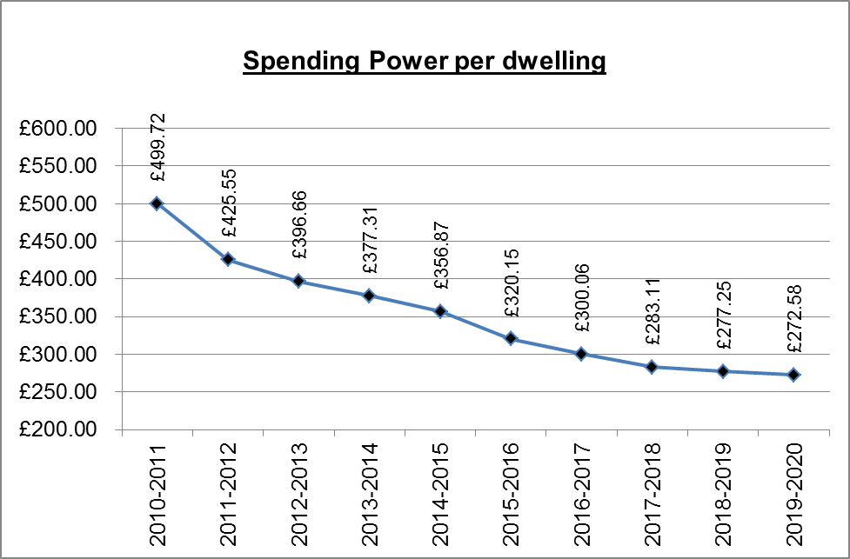

Members had been requested to note that the Core Spending Power excluded the Housing Revenue Account.

RESOLVED:- To note the information.

REFERRED ITEMS

THE FOLLOWING MATTER WAS REFERRED TO COUNCIL FOR DECISION

39 – Waste Policies

The Corporate Support Manager reported that at the last meeting of this Committee Members had agreed that the waste policies should be reviewed in advance of the new contract commencing in April 2017. He advised the Committee that the policies had been reviewed in conjunction with himself, the Corporate Support Assistant, Councillor M. A. Thomson (Spokesperson for the Environment) and the Streetcare Manager.

The updated policies including the Cleaner Neighbourhoods Environment Act Enforcement Policy and the Waste Container Exceptions Policy had been appended to the report for Members’ information. Members had been invited to view the policies and recommend that the policies be endorsed by the Executive Committee.

A Member advised that he had spoken with the Council’s Recycling Officer regarding carrying out some recycling promotion activities in schools in the area. The Corporate Support Manager would follow up this matter with the Recycling Officer.

The Corporate Support Manager informed the Committee that in line with the Council’s Waste Minimisation Strategy, the Council would work in partnership with FCC to expand kerbside collection of recyclable materials to include tetrapaks and tin foil. The method of presenting waste would be a 55 litre box for glass only and a 240 litre burgundy coloured wheelie bin for the other recycling which could be co-mingled including: card, paper, plastic, cans, foil and tetrapaks.

RECOMMENDED:- That the revised Cleaner Neighbourhoods Environment Act and Enforcement Policy and Waste Container Exceptions Policy be endorsed by the Executive Committee.

The meeting closed at 2.42 p.m.

