Welcome To The Barrow In Furness Area

Welcome to Barrow in Furness – the maritime gateway to Cumbria – The Lake District – A proud Victorian town whose prosperity was built on iron and steel and Vickers Armstrong : Shipbuilders to the world.

In this leaflet:

Welcome To The Barrow In Furness Area 1
THINGS TO SEE AND DO IN BARROW 2
Shopping 2
The Dock Museum 3
Furness Abbey (English Heritage) 3
Barrow-in-Furness Town Hall 4
Piel Castle (English Heritage) 4
South Lakes Wild Animal Park 4
Dalton Castle (National Trust) 4
Sandscale Haws Nature Reserve 5
South Walney Nature Reserve 5
North Walney National Nature Reserve 5
Golf 6
Horseriding 6
Kitesurfing 7
Wax Lyrical 7
Karting & bowling centre …………………………………………………………….7
THINGS TO SEE AND DO IN ULVERSTON 8
Shopping 8
Conishead Priory 8
Sir John Barrow Monument 9
Laurel and Hardy Museum 9
The Lakes Glass Centre (incorporating Cumbria Crystal and Heron Glass) 9
Gleaston Water Mill (close to the Coast Road between Barrow and Ulverston) 9
Swarthmoor Hall 10
THINGS TO SEE AND DO IN THE LAKE DISTRICT 11
BARROW PORT AND TRANSPORT INFORMATION 12
Pre book Taxis 12
Blue Badge Driver Guide Tours 13
Normal Operating Hours 13
How To Get To 13
Shuttle Bus Information 13

THINGS TO SEE AND DO IN BARROW

Welcome to Barrow in Furness – the maritime gateway to Cumbria – The Lake District – A proud Victorian town whose prosperity was built on iron and steel and Vickers Armstrong : Shipbuilders to the world.

Many sites of interest are to be found in and around the town, from the magnificent ruins of Furness Abbey and the charming mysteries of Piel Castle, to peaceful expanses at Roanhead with breathtaking views of Black Combe to the north. The ancient market town of Dalton, formerly the capital of Furness and birthplace of George Romney the renowned portrait painter, lies a few miles to the north and is home to South Lakes Wild Animal Park and nearby Sandscale Haws Nature Reserve. Unspoilt sandy beaches, bird sanctuaries and nature reserves offer a haven for those searching for peace and tranquillity.

Shopping
Barrow is Cumbria’s largest town where major national stores such as Debenhams, and Marks and Spencer mingle with local specialist shops in a spacious pedestrianised town centre. The big names can be found in Portland Walk and along Dalton Road whilst Cavendish Street, Scott Street, Buccleuch Street, Rawlinson Street, Crellin Street, and Portland Walk Arcade offer a wide variety of independent retailers offering exceptional value, variety and personal service.

Local Specialties/Souvenirs: The Dock Museum shop has a wide range of local and Lake District Souvenirs – free admission. Furness Abbey Visitors Centre also has a charming selection of gifts and souvenirs.

Barrow has most of the Big High Street Names of the United Kingdom including Marks and Spencer, Debenhams, Boots, New Look etc and lots of specialist shops selling jewelry, clothing, perfumes, gifts, china, shoes, cameras, memory cards and digital printing.

For the bargain hunter, Barrow’s Indoor Market has over 80 stalls and is open on Mondays, Wednesdays, Fridays, and Saturdays.
Stalls stock over 100 locally produced food items, fancy goods, clothes, luggage etc.

On the edge of town there are large retail parks with ASDA, Tesco and Morrison Supermarkets. Morrison is only a couple of minutes walk from the Shuttle bus drop off at The Town Hall and Tesco is opposite the Dock Museum.

Specialist electrical suppliers eg Currys & PC World stock computer and photographic requisites.

Some shops offer a discount for passengers and crew on production of your cruise card. Details will be available on the quayside and on the shuttle buses.

US Dollars Accepted? no
Credit Cards Accepted? Yes

Sunday Shopping : Due to UK Sunday trading laws large shops and supermarkets can only open for 6 hours. Barrow Market and many of the Town’s small independent shops do not open on Sundays.

The Dock Museum
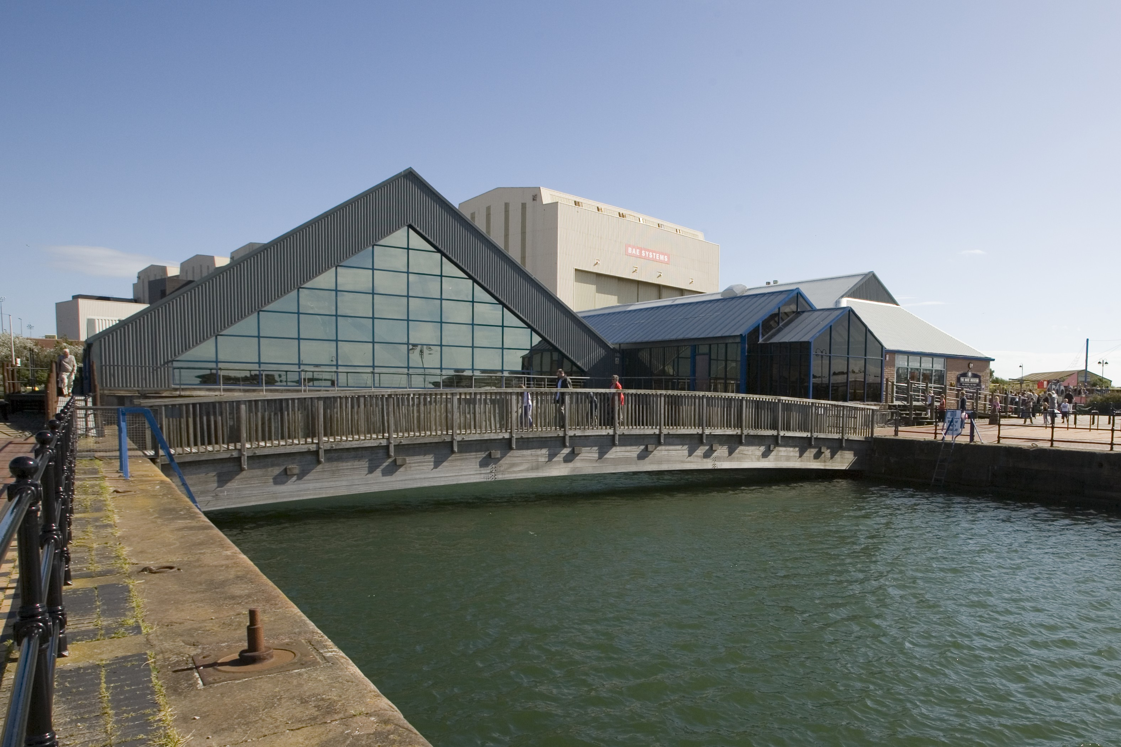
This exciting and innovative museum opened in 1994. Built over an original Victorian Graving Dock, it traces the history of Barrow from a tiny 19th Century hamlet to the world’s largest producer of tin and steel and then to a major ship-building force, within 40 years. The story of the people who brought about such change is both unique and extraordinary. A spectacular new permanent exhibition ‘Shipbuilders to the World’ includes the museum’s collection of fine ship models and exciting computerised interactive displays using images from the photographic archive. Barrow shipyard built many ocean liners and cruiseships especially for the Orient line and there is a marvellous exhibit featuring a magnificent Ship model of the Oriana. The museum also hosts the Furness Hoard – a Viking hoard of silver jewellery and coins discovered on the outskirts of Dalton-in-Furness within its Viking Gallery. A free shuttle bus will operate to the Museum during cruise ship visits. Tel 01229 876400 or visit www.dockmuseum.org.

Furness Abbey (English Heritage)
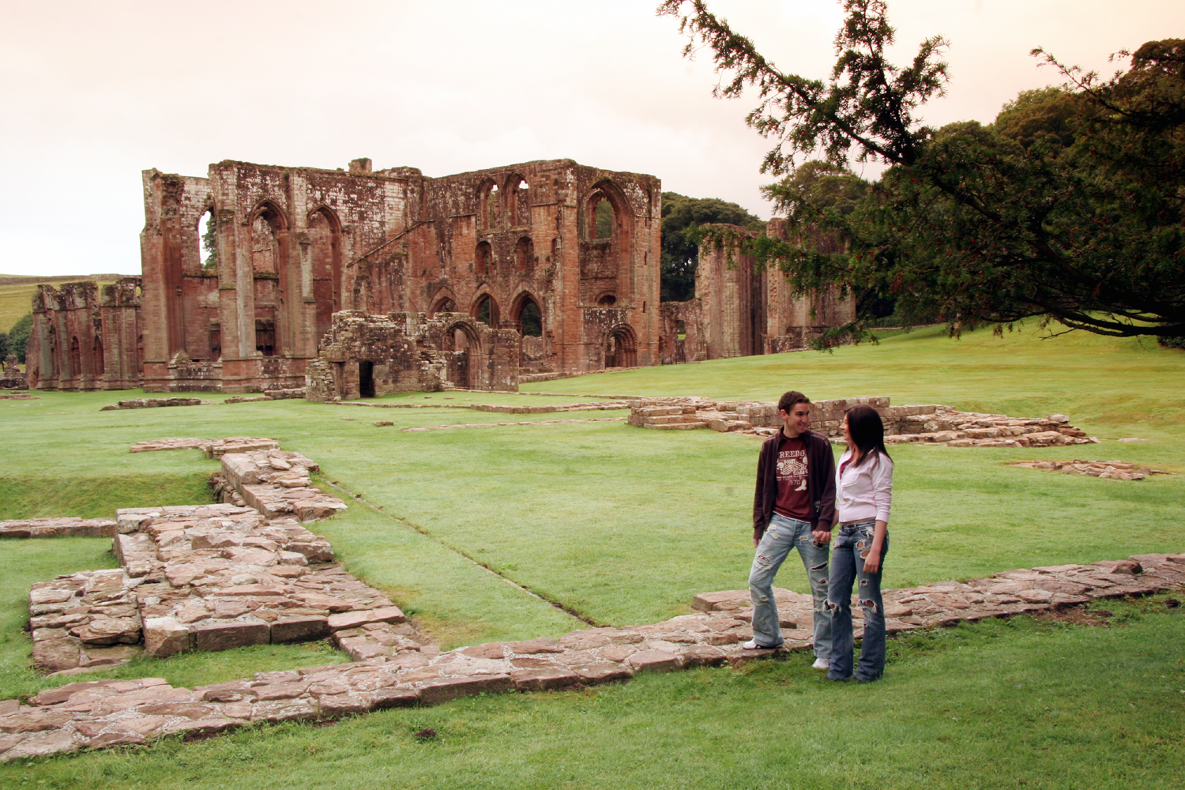
The Abbey of St. Mary of Furness is a, a magnificent ruin of a vast and imposing building constructed in the distinctive local red sandstone and set in the deep, wooded valley of Bekansgill. The Abbey was founded in 1127 on land granted by Stephen, who was at that time Count of Boulogne and Mortain and later became King of England. The governing monastic order was originally Savigniac, an order dedicated to learning and prayer, but by order of the Abbot of Savigny the Abbey became Cistercian in 1148. It was the second wealthiest Cistercian Abbey in England. With the Dissolution of the Monasteries in 1537, the lead roof from the Abbey was removed and melted down and the walls partly demolished. The Abbey ruins are currently being stabilized and during this work a previously undiscovered grave of an Abbott was found. This contained a crozier and ring, and these are on display in the Visitors Centre. Tel 01229 823420 or www.english-heritage.org.uk. A free shuttle bus will link the Dock Museum with the Abbey during Ship visits.

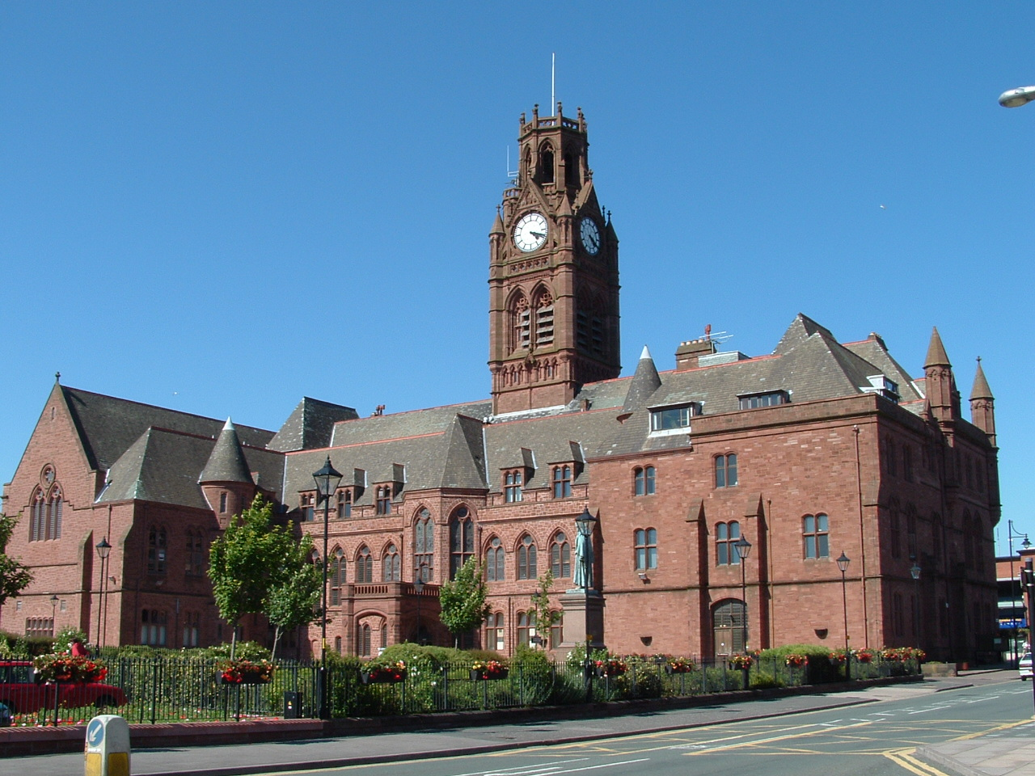
Barrow-in-Furness Town Hall
Barrow’s impressive Town Hall is at the heart of the town and its clock tower can be viewed from almost anywhere in the vicinity. Built from local red sandstone, it was formally opened in 1887 and represents the height of Barrow’s Victorian development. The building was designed by W.H. Lynn in the style known as modern Gothic. The richest detail of the interior can be found in the oak panelled Council Chamber and the Queen’s Hall, with its dazzling stained glass. The building is still at the centre of the everyday running of the Borough of Barrow-in-Furness.

Piel Castle (English Heritage)
Once the last bastion of defence from the marauding Scots, Piel Castle is now in ruins. Built around 1327 it was mainly used as a fortified warehouse for the storage of grain and wool. In 1487 it was invaded by Lambert Simnel and over 2,000 of his followers on the start of their abortive attempt to seize the crown from Henry VII. The landlord of the public house on the island, The Ship Inn, holds the title “King of Piel”. The only means of access is via the Roa Island ferry service or a guided walk across the sands at low tide. Your ship will sail down Walney Channel and past Piel island as it enters the port of Barrow. To arrange a visit please contact Steve Chattaway, the King of Piel Island at pielisland@tiscali.co.uk.

South Lakes Wild Animal Park
One of Europe’s finest conservation animal parks housing some of the world’s rarest species. Take a “Safari on Foot”, hand feed penguins or become a keeper for a day. Uniquely to Britain it is home to both Sumatran and Siberian tigers as well as African lions. There are animals from many continents, some free roaming, and informative talks featuring endangered species such as rhino and tigers are a highlight of any visit. For more information visit www.wildanimalpark.co.uk.

Dalton Castle (National Trust)
The castle was built in stages between the 1330’s and 1350’s, perhaps in response to a series of Scottish raids earlier that Century. It was changed several times before undergoing its most radical alteration in 1856. The Castle served as a courthouse and dungeon for Furness Abbey. After the dissolution of the monastery in 1537 the Castle passed through several hands, eventually resting with the Dukes of Buccleuch. It was the 8th Duke who presented the Castle to the National Trust in 1965.A National Trust guidebook is available and there is an exhibition celebrating the life and work of George Romney, the renowned portrait artist, who is buried in nearby Dalton Church. The castle is open by appointment by telephoning 01229 463293.

Sandscale Haws Nature Reserve
Coastlines can come and go with the changes in tides and winds. The National trust nature reserve at Sandscale Haws is a growing landscape; sand is deposited on the shore and is blown into a broad range of spectacular dunes. Behind these yellow dunes are slacks or marshy hollows. The mix of wildlife habitats is unique. Flowers abound, including specialities like the dune pansy, sea holly and sea bindweed and in the spring pools of water in the slacks are the breeding sites for natterjack toads and great crested newts. In summer the slacks dry out and there are drifts of marsh orchids and clouds of blue butterflies. Tel 01229 462855.

South Walney Nature Reserve
South Walney Nature Reserve is situated on the south end of Walney Island, on land granted by King Stephen to the Abbot. It contains the largest, mixed ground nesting of herring and lesser black-back gulls in Europe (almost 30,000 pairs altogether) and the most southerly eider duck breeding colony in Britain. Other breeding species of birds include the greater black-back gull, common tern, little tern, oyster-catcher, ringed plover, shellduck, mallard and moorhen. The area has considerable ecological interest arising from the many habitats present, including mudflats, pebble ridges, salt marshes, sand dune, rough pasture, freshwater and brackish pools. It contains an excellent range of both the common and rare flowers of the coast. Tel 01229 471066.

North Walney National Nature Reserve
One of the main reasons for the reserve is the presence of natterjack toads, Britain’s rarest amphibian. There are only about 40 remaining sites, and one of their main strongholds is the Cumbrian coastline. The calling of males in the breeding season is very impressive. Visitors are reminded that it is illegal to capture or keep natterjack toads without a licence. Additionally, over 130 species of birds have been recorded on and around the reserve including a large number of kestrels, sparrowhawks, merlins, peregrines and hen harriers. Short-eared owls are also frequent visitors, to be seen hunting before dusk. Recent visits by rare species include the beautiful golden oriole. The area is very rich in flora, with a staggering 300 different species having been recorded.

Golf
Several excellent golf courses are within easy reach of Barrow. The Barrow Golf Club at Hawcoat, and the attractive links course of the Furness Golf Club on Walney Island, both have 18 holes and are reasonably priced. Furness Golf Centre has a driving range and a 9 hole course.

Name of Club | Type of Course | Contact Details | Distance from Port
Barrow Golf Club (Hawcoat) | 18 hole course | Tel 01229 825444  www.barrowgolfclub.co.uk | 4.4 miles
Furness Golf Club, Walney Island | 18 hole links course | Tel 01229 471232  www.furnessgolfclub.co.uk/ | 3 miles
Furness Golf Centre | Driving Range | Tel 01229 465890 | 5.6 miles
Dunnerholme Golf Course | Unique 10 hole course | Tel 01229 462675  atantalus.com/dunnerholme | 8 miles

Horseriding
Horse riding facilities are available through Seaview Riding School:-
(01229) 474251 or (01229) 475315.

Kitesurfing
Walney Island hosts the British National Kitesurfing Championships each summer. For an adreneline rush contact North West Kitesurfing on 01229 470303 or e mail info@nwks.co.uk.

Wax Lyrical
Lindal, which is just to the north of Dalton on the A590 is a quaint village set in the undulating countryside of Furness with a history allied to the mining activity in the area. Lindal is home to Wax Lyrical the UK’s leading candle manufacturer and the most experienced producer of scented candles in Europe.

GoCumbriakarting and GoCumbriabowling
This indoor bowling and Karting centre is situated on the outskirts on Barrow at James Freel Close. Tel 01229 833250 or visit www.gocumbriakarting.co.uk

THINGS TO SEE AND DO IN ULVERSTON

Welcome to the Lake District Peninsulas and Ulverston. Ulverston is an ancient market town famed as the birth place of Stan Laurel and home to the world famous Laurel and Hardy Museum.

There is much to interest the visitor in the town and the surrounding countryside. Ulverston’s cobbled streets are lined with fascinating buildings predominantly built in the 18th and 19th Centuries. One of the many claims to fame for the town include he originating pole-vaulting as a competitive sport at the beginning of the 20th century.
Granted a charter from Edward 1 to hold street markets and fairs in 1280, Ulverston still holds weekly sheep and cattle markets at the Auction Mart close to the eighteenth century built Canal. The weekly street markets are held on Thursdays with some stalls on Saturdays.

Shopping
Ulverston’s specialist and friendly shops provide a mouth-watering mix of contemporary and traditional shopping spiced with many well-known brands that create a recipe for a unique shopping experience with a difference. Buy anything from an original painting, a ball gown, to local crafts, antiques or second hand books. The Market and majority of shops are closed on Sundays.

Conishead Priory
Conishead Priory was originally founded by Augustinian monks in 1160 as a hospital for the poor. The present mansion was built in 1820 as a family home and has been used as a hydropathic hotel, military hospital, miners’ convalescent home and is now a large residential Buddhist Centre. Dominated by two 100-foot octagonal towers, the present house is an excellent example of Victorian Gothic architecture. Special features include decorative ceilings, a vaulted great hall with fine stained glass and a 177 feet long cloistered corridor. The Priory grounds stretch to the coastal shore with many fine specimen trees and just off shore is Chapel Island where it is said the original monks kept a light burning to signal to those crossing the treacherous sands of Morecambe Bay from Lancaster that they were close to making land fall at Canal Foot.

Sir John Barrow Monument
The Sir John Barrow Monument is a most impressive land mark high up on Hoad Hill overlooking the town. Modelled on an earlier version of the famous Eddystone Lighthouse the Monument was built in 1850 to commemorate the life of a famous son of Ulverston Sir John Barrow. Born in Ulverston on 19th June 1764 the young John joined a Whaling expedition to Greenland. In 1804 he was appointed Second Secretary to the Admiralty and was the senior Civil Servant who oversaw the Battle of Trafalgar. The monument is 100ft high and constructed from local limestone. It can normally be accessed by climbing 112 interior stone spiral steps from the ground floor. There are magnificent panoramic views from the Hill and from the top of the Lighthouse. It is possible to see Morecambe Bay, the Yorkshire Dales, the Lakeland Fells to the North, Blackpool Tower to the south and on a very clear day the North Wales hills. The Monument is not open to the public at the moment whilst work is carried out to protect the fabric of the building from damp. However, a walk up to the top is well rewarded with 360 degree views.

Laurel and Hardy Museum
This world famous museum is located in the town where Stan Laurel was born on 16th June 1890. The late Bill Cubin, the founder of the museum devoted his life to these world famous comedians and collected an amazing variety of memorabilia, believed to be the largest in the world, including letters, photographs, personal items and furniture. A statue of Laurel and Hardy is sited in County Square adjacent to the Coronation Hall.

Gleaston Water Mill (close to the Coast Road between Barrow and Ulverston)
In a truly rural location, the mill is the perfect place to relax, explore and discover England’s heritage; with fascinating facts about the miller, his mill, his machinery, his pigs and his bees. Visit Dusty Miller’s tearooms, Pigs Whisper Country Store, observation hive and training apiary.

Swarthmoor Hall
Swarthmoor Hall is an Elizabethan manor house set in some 100 acres of organic farmland on the outskirts of Ulverston. It was built in about 1586 to become the family home of Judge Thomas Fell who was Chancellor to the Duchy of Lancaster. In 1652, George Fox – the person seen as the principal founder of the Quaker Movement - came to the Hall to meet with Judge Thomas Fell and his wife Margaret. Margaret was totally convinced by Fox’s preaching and Swarthmoor Hall became the “powerhouse” and cradle of early Quaker Movement.

THINGS TO SEE AND DO IN THE LAKE DISTRICT

Within a short drive of Barrow-in-Furness there are a wealth of Cumbrian towns and villages steeped in the cultural traditions of the Lake District and reached by scenic routes through stunning countryside, alongside majestic lakes, the inspiration for artists and Romantic poets over generations.

Explore Coniston and enjoy a sail on Coniston Launch or the elegant Steam Yacht Gondola. Cross the lake on a short cruise to visit Brantwood, the beautiful home of John Ruskin on the eastern shore of the Lake. Memories of Donald Campbell and the water speed record can be seen amongst the magnificent local history collections at the Ruskin Museum back in the village.

Visit Grasmere and Dove Cottage William Wordsworth’s most famous home and nearby Rydal Mount, his last, much loved house. The churchyard of the 13th century house is the resting place of several Wordsworth family members. Sample a local delicacy Sarah Nelson’s Grasmere Gingerbread.

Experience Ambleside styled “the walking capital of South Lakeland”. For the adventurous hike to the top of Loughrigg and Wansfell with spectacular views as your reward. Take a cruise on Windermere, England’s longest lake with Windermere Lake Cruises down to Bowness-on-Windermere and the neighbouring town of Windermere.

Visit the World of Beatrix Potter attraction and Blackwell, overlooking Windermere, one of the finest Arts and Crafts houses in the country.

Hawkshead, a delightful village of traditional Lakeland cottages and narrow streets is close to Hill Top, home of Beatrix Potter.

Kendal, home of the famous mint cake has an ecletic mix of high street names, speciality shopping and an expanding café culture.

BARROW PORT AND TRANSPORT INFORMATION

- Dock or Anchor?: Dock alongside no 4 berth accessible off Cavendish Dock Road
- Is pier wheelchair accessible? Yes
- Distance from Gangway to bus: Immediately adjacent
- Distance Pier from Town Centre 1.4 miles. Can You Walk? Shuttle buses will be provided free of charge but it is possible to walk
- Taxis Available at Pier? Yes Cost to Town Centre: £3. US$ Accepted? No
- Taxis Metered? Yes. Hourly Rate: £30.
- Phones Available at Pier? No, nearest in Town Centre behind the Town Hall and on Dalton Road. Payphones are also available in the Indoor Market and the Tourist Office in Forum 28. – phone cards and currency is available the from post office nearby
- Bureau de Change: Thomson, Thomas Cook, First Choice and Co-op Travel and Post Office on Dalton Road, Provident Finance and Post Office on Duke Street
- Cash Point: There is a cash point in Wilkos opposite the Town Hall and Tesco opposite the Dock Museum
- Car Hire: Hertz Tel 01229 836666 www.hertz.co.uk; Enterprise Tel 01229 820055, www.enterprise.co.uk (can be booked on line and passengers collected from quayside)

Pre book Taxis
- A1 CARS - 838383 at info@838383.co.uk or tel. 01229 838383 (8 & 6 seat vehicles also available)
- ACACIA CARS - 434343/830055
- ALS TAXIS - 823324
- ANDYS - 462309
- AVON CARS - 473773/472607
- BARROW CARS - 820005/820174
- CAPITAL CABS - 0780 265 3447
- CAREFREE TRAVEL – 829217 (disabled access vehicles also available)
- CENTRAL CARS - 870444/836634
- COASTLINE - 824504
- DALTON AIRPORT SERVICES - 466720
- DALTON CARS - 462499
- DAVE & VALS - 839144
- HANDS ON SUPPORT - 430465
- J.C. -870000
- PARK LANE TRAVEL - 471307
- ZEPHYR ESCORT - 822056
- Pre book stretch limousine tel The Full Stretch on 01229 465503 www.fullstretch.co.uk or e mail fullstretch@freenetname.co.uk

Blue Badge Driver Guide Tours
Cumbrian Discoveries Tours offers the passenger to explore and experience the English Lake District with a qualified blue badge driver guide.
For more information visit www.cumbriandiscoveries.co.uk or email info@cumbriandiscoveries.co.uk

Normal Operating Hours

Banks: MON-FRI 9.30 am – 4.30 pm
Shops: MON-FRI 9am – 5.30 pm
Dock Museum: 8.30 am – 5 pm (special early opening for ship visit)
Post Office: MON-FRI 9 am – 5.30 pm (Has Bureau de change)
Barrow Market: 9am – 5 pm Mon/Wed/Fri/Sat

How To Get To

Destination | Distance from Ship | Taxi Cost
Beaches | 3.4 miles | £6.40
Train Station | 2 miles | £4
Bus Station | 1.4 miles | £3
Ferry Terminal | n/a
Shopping Centre | 1.4 miles | £3
Airport | 120 miles | £100.00
Catholic Church | 1.4 miles | £3
Protestant Church | 1.1 miles | £2.50
Synagogue | n/a
Cyber Cafe | 1.6 miles | £3
Tourist Information Center desk | On the Quayside
Tourist Information Centre main office | 1.4 miles | £3

Shuttle Bus Information

Free Shuttle buses will be provided from the Quayside to the Town Centre and from the Quayside to the Dock Museum and Furness Abbey.
There will be a low access vehicle which can also carry passengers in wheelchairs for the Town Centre shuttle service only. The shuttle buses will run a continuous shuttle service commencing at 9 am. The last shuttle bus will leave the Town Hall 45 minutes before the ship sails..

A Heritage shuttle to the Dock Museum and Furness Abbey will run to a timetable The first bus will depart the quayside for Furness Abbey at 9.30 am and the last bus will leave the Furness Abbey at 5 pm.

Shuttle buses will be available to passengers and crew.

