Cumbria Landlord Accreditation Scheme
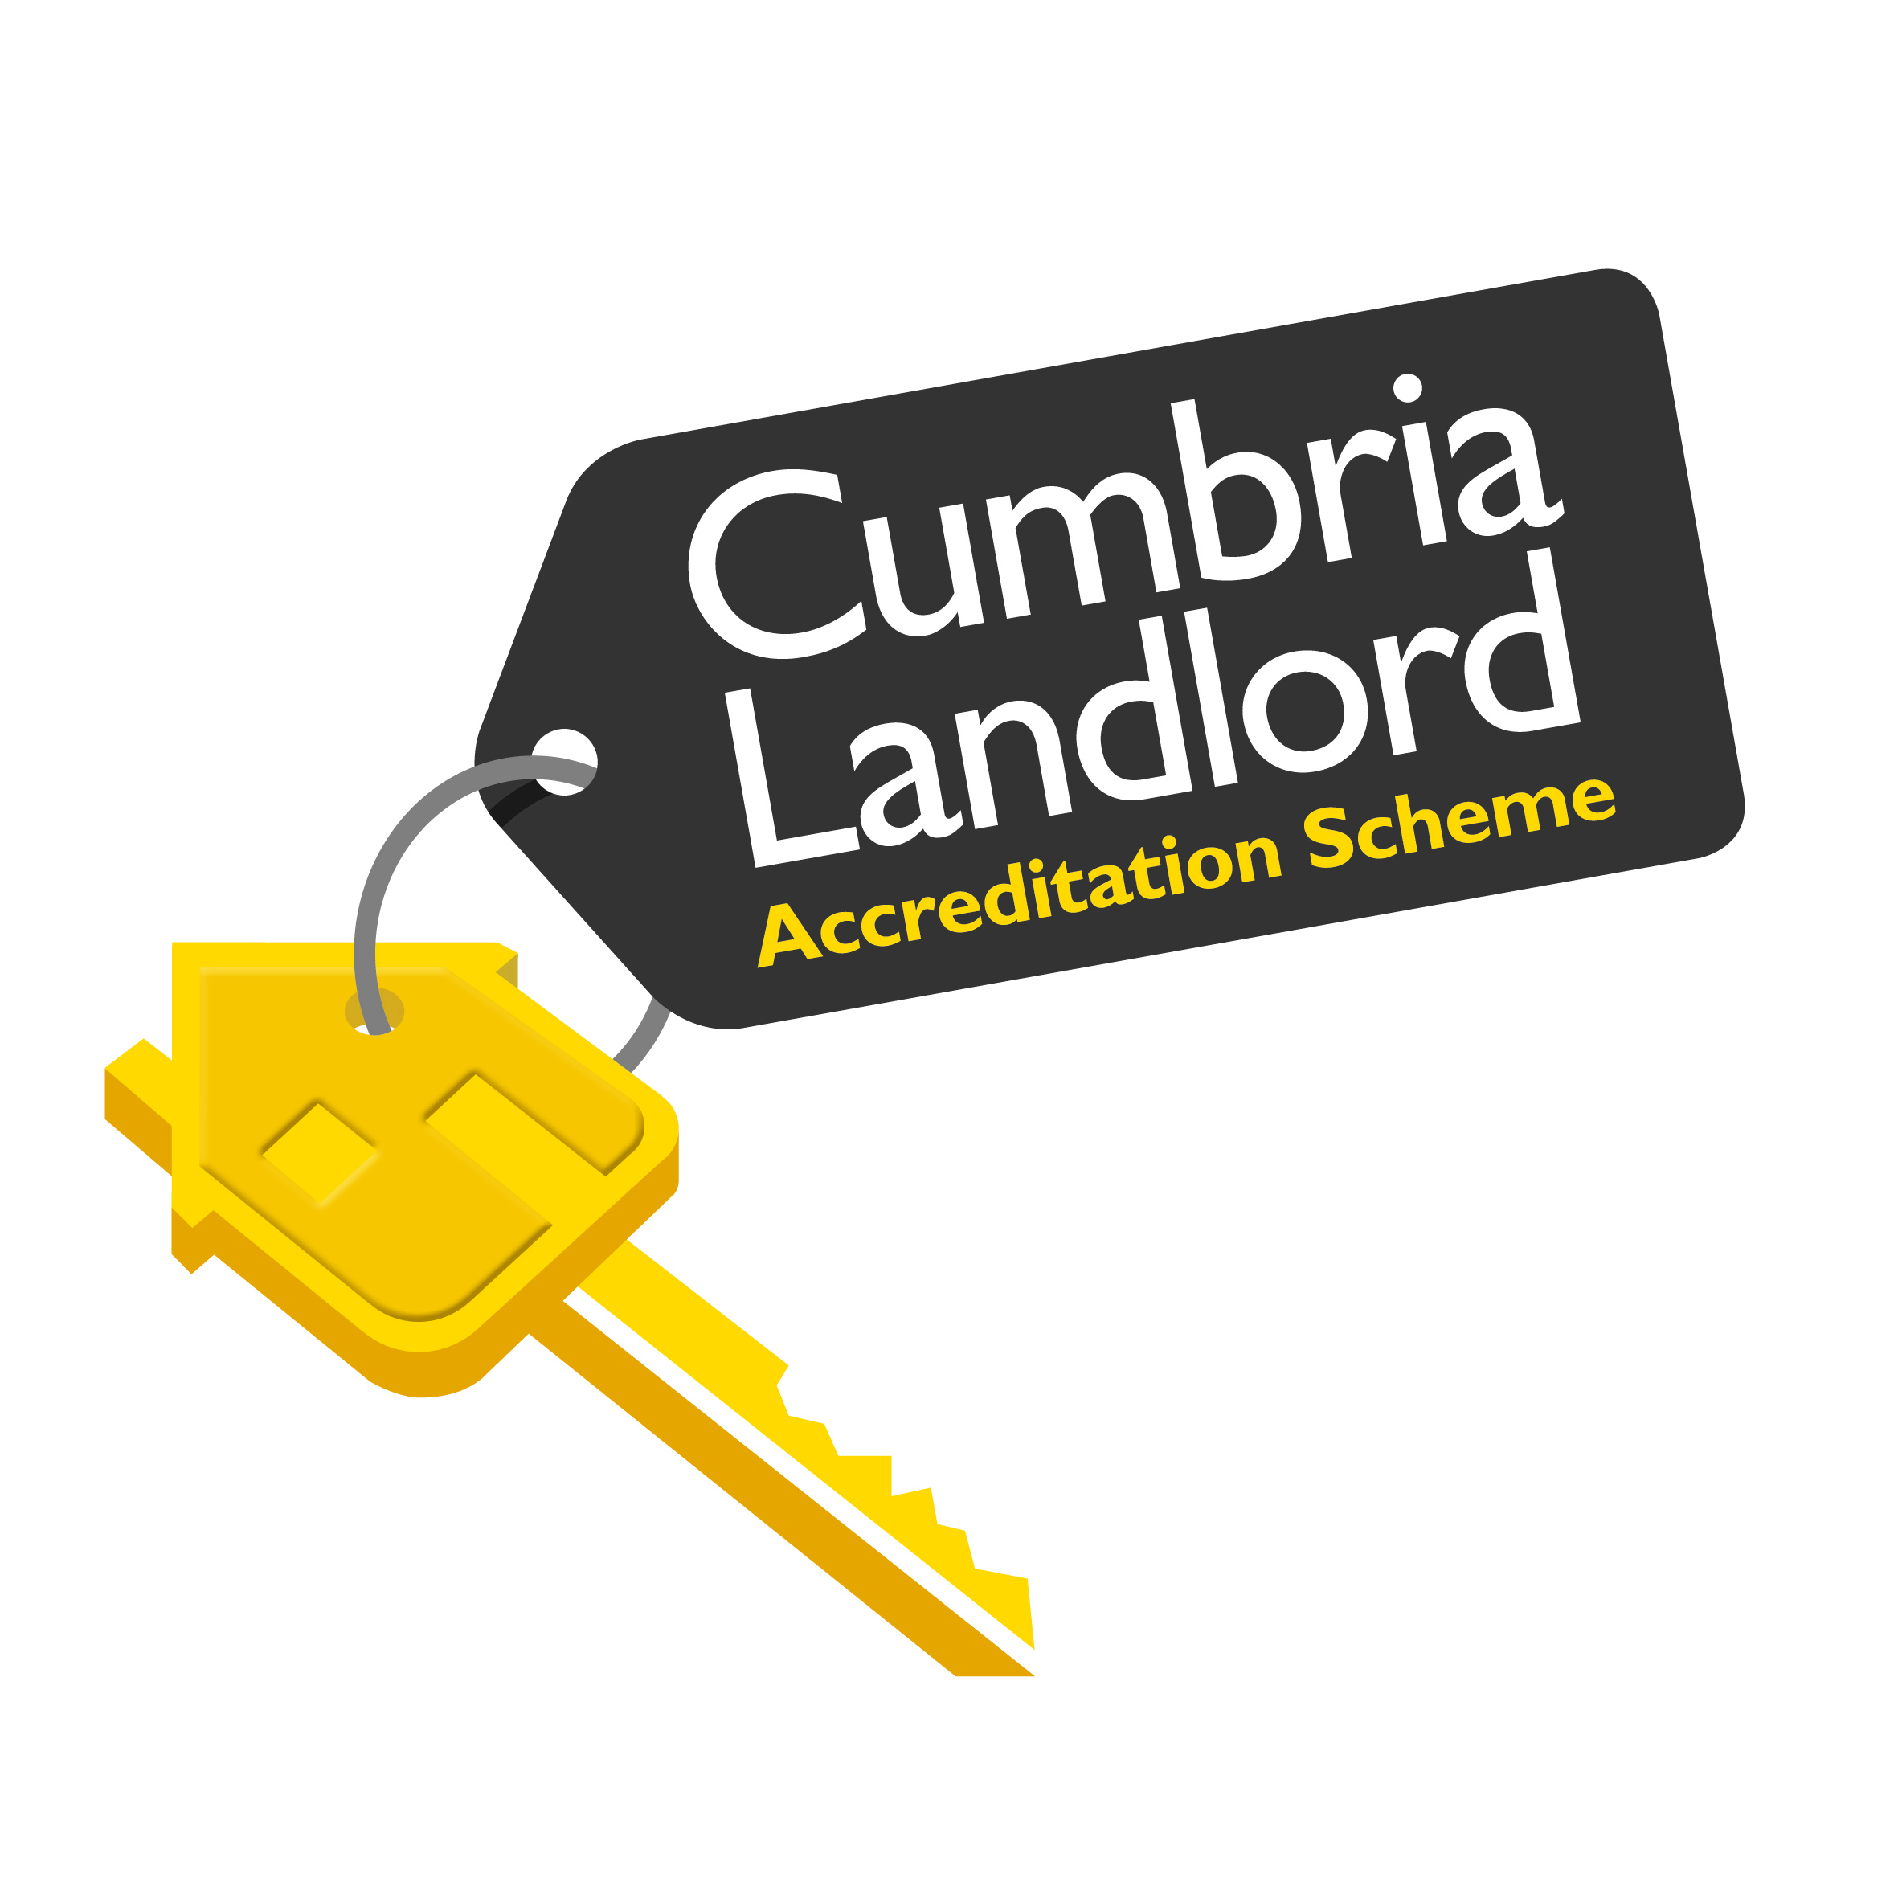

The districts of Allerdale, Barrow, Carlisle, Eden and South Lakeland have formed a partnership with the National Landlords Association (NLA) to administer the Cumbria Landlord Accreditation Scheme on their behalf. In addition to the benefits the NLA offer their members, there will be local incentives offered to accredited landlords by the individual local authorities.
The Scheme was launched on 20 May 2014 and comes fully into effect on 1 October 2014.
The information below, from the NLA, explains how landlords can join the scheme:

What is NLA Accreditation?
Accreditation of landlords has been a feature of the private rented sector for more than 15 years. It is the certification that a product or service has been evaluated independently and meets an agreed standard.
Accreditation is becoming increasingly important and has been adopted by councils as a way of ensuring that goods and services are safe within the private rented sector. Councils often base their Accreditation schemes on Property inspections, awarding the landlord with accredited status once a percentage of their properties have been inspected.
NLA Accreditation is purely based on Landlord Development and good management practice. It is a national scheme which offers greater consistency for all landlords, tenants and councils to recognise.

How do I become accredited?
There are three ways that you can become accredited with the NLA :
1) Attend one of our foundation courses to become accredited. The course is facilitated across the UK. To find your nearest course visit our events calendar www.landlords.org.uk/events/product_course
2) Complete the course online by visiting the Library home page logging in and then completing all of the "CORE" subjects in www.landlords.org.uk/library
3) Passport on to our scheme from other similar development based models such as LLAS, MLAS or Landlord accreditation wales (LAW) You will need to download and sign the scheme rules along with providing proof you are a member of a development based scheme that follows the same syllabus as the NLA. This can be in the form of your accredited certificate.
However you chose to become accredited all landlords are required to sign the scheme rules document and return it to accreditation@landlords.org.uk

The benefits of becoming an NLA Accredited landlord
The NLA promotes and provides accreditation because we believe it is the best way for us to prove, as landlords, that we can self-regulate.
If we are aware of legislation and our responsibilities and have a way of demonstrating this we can prove that we do not require further legislation in the private rented sector.
The NLA accredited logo is a clear way to demonstrate that you are a professional landlord to your tenants. A number of local authorities also provide discounts to accredited landlords including reductions on HMO licences.
The more accredited landlords we have the bigger our voice will be in gaining greater benefits for accredited landlords.

Local Authorities recognise NLA Accreditation status
The participating local authorities in Cumbria will offer incentives to NLA accredited landlords.

A mark of quality
NLA Accreditation is based on landlord development and is a national scheme that all tenants in England, Scotland and Wales can recognize as a mark of quality.
Tenants are encouraged to verify their landlord is a member of the NLA (and accredited) by using our online verification register.
- See more at: http://www.landlords.org.uk/support-advice/landlord-accreditation#sthash.s93DO87w.dpuf
For more information
If you have any questions about the CLAS scheme and the local incentives offered by your local council please contact:
Private Sector Housing Team
Barrow Borough Council
Town Hall
Barrow-in-Furness
LA14 2LD
Tel 01229 876543

