A shared vision, a single voice for housing in Cumbria

The Cumbria Housing Strategy and Investment Plan
2011 – 2015

October 2011

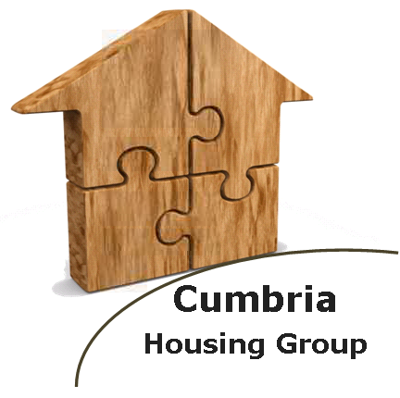

Contents
Purpose 4
Key themes 4
Key Theme 1: Housing Growth, Affordability and Community Sustainability 4
Key Theme 2: Vulnerable People, Supporting Independence 5
Key Theme 3: Housing Market Renewal: Using Stock More Effectively 5
Background 5
The impact of housing on… 7
Vision 8
The National Context 8
Housing & Welfare Reforms 8
Finance Reforms 10
Planning Reforms 11
Local Enterprise Partnerships 12
Health Reforms 12
Current position: where are we? 13
The spatial context of Cumbria: settlements and boundaries 14
Cumbria: A strategic overview 15
The Local Context 17
The Economy 17
Demographics 17
Barrow-in-Furness, Copeland and Allerdale 17
Eden and South Lakeland 19
The National Parks 19
Carlisle 20
The Future: where do we want to be and how will we get there? 21
Where do we want to be? 21
Key Theme 1: Housing Growth, Affordability and Community Sustainability 21
Key Theme 2: Vulnerable People, Supporting Independence 22
Key Theme 3: Housing Market Renewal: Using Stock More Effectively 24
Action Plans 24
Our Approach 25
How will we get there? 26
Appendix 1: Source list- The impact of housing on… 28
Appendix 2: Development Priorities 29
Appendix 3: SWOT Analysis 30
Appendix 4: Progress of the Local Development Framework by
Local Authorities in Cumbria 31

Purpose
This strategy has been produced in partnership through the Cumbria Housing Executive Group. The Group comprises representatives from the 6 District Councils (as the strategic housing authorities), the Lake District National Park, Cumbria County Council, a Registered Providers’ (housing associations) representative and the Chair of the Housing Forum. Representatives on the Cumbria Housing Executive Group have clear mandates to work together to realise our vision:

A shared vision, a single voice for housing in Cumbria. We are committed to working together to add value; to create, sustain and enhance homes and communities for the benefit of all.

We recognise that by working together with our wider partnerships, we can add real value to creating and sustaining homes and communities across Cumbria, that respond to changing social and economic needs. The purpose of this strategy is to set out our collective plan detailing our vision, high level key themes and objectives from 2011 to 2015 and to articulate how we will:
- Speak with a single voice to promote the uniqueness and diversity of Cumbrian communities;
- Influence wider agendas to the benefit of all people in the communities across the districts of Cumbria;
- Deliver against our agreed key themes.

Key themes
Based on evidence and local expertise we have identified three key themes where we want to make progress over the course of this strategy; these do not reflect the entirety of the issues faced by Cumbrian communities but are the key areas where Cumbria Housing Executive Group feel we can add value and make a difference.

Key Theme 1: Housing Growth, Affordability and Community Sustainability

We want housing which supports a growing economy and sustainable communities and where the need for affordable and market housing to support economic opportunities identified by the LEP, are delivered. We want to see the housing needed to develop the rural economy, delivered. We want to maximise funding opportunities around growth and use collective procurement to achieve cost effective delivery of new public sector housing. We want the development of new housing to be underpinned by improvements to the physical infrastructure and to support improvements to health and well-being.

Key Theme 2: Vulnerable People, Supporting Independence

We want vulnerable people to be empowered to live independently with the ability to purchase the care/support needed to maintain their tenancy and fully engage in their local community, either through access to personal budgets, direct payments and/or Supporting People provision regardless of gender, ethnicity, disability, age, sexuality, or faith. We want vulnerable people to have access to extra care housing (as and when appropriate); to energy saving and disability adaptations grants (i.e. through an effective and efficient Disability Facilities Grant programme); to banking and credit; and to paid employment or a supported employment programme moving people towards the world of work. We want vulnerable people to be empowered to maximise their life chances as young adults by having access to accommodation that supports their employment, education and training living in and contributing to safer and stronger communities.

Key Theme 3: Housing Market Renewal: Using Stock More Effectively

We want to continue support for housing market renewal including an increase in the choice and quality of housing stock and the regeneration of our oldest and poorest housing. We want to maximise the potential of the existing (private and public sector) housing stock so that significant progress is made in adapting homes to meet special needs, bringing empty and under-occupied homes into beneficial use, eliminating sub-standard housing, improving energy efficiency and matching the stock to the needs of tenants through an expanded choice based letting scheme. We want tenancy strategies in place that seek to ensure that social housing assists in meeting current and future housing need, maintains stable communities and that best uses stock to eliminate overcrowding and under occupancy. We want mechanisms established to ensure that second homes/holiday homes do not form more than 20% of the local housing market.

Background
In Cumbria the housing sector has been working in partnerships for a number of years to develop a cohesive response to the housing issues faced by all the diverse communities across the districts. A Cumbrian Housing Strategy was developed for the period 2006-2011; this was the first sub-regional housing strategy in the country. The vision for this strategy was that, “Cumbria will have balanced housing markets supporting the social and economic changes that our county will undergo over the next 20 years.” The previous strategy 2006 – 2011 identified five key housing issues across Cumbria:
- Shortage of Affordable Housing;
- Creating decent homes and environments;
- Housing the homeless;
- Regeneration; and
- Homes with support or additional facilities.

Since 2006 the economic climate has fundamentally changed and more changes are underway to deal with the implications of this. The timing is therefore right for a new strategy to be developed which responds to the needs of the diverse communities across the districts and county.

This document will review the current national and local context to provide an overview of where we are, where we want to be and outlining our shared aspirations for the future.


The impact of housing on…
…Economic growth
…Health and well being
In the North West there are 27,000 new households forming per year and only 9,800 new homes (09/10) (1).
Housing, health, care and support sectors should ensure people remain healthy and engage with their communities: no action would mean a 325% increase in costs by 2041 (12).

House building throughout England is at its lowest level since 1924 (2).
Homelessness directly impacts on a person’s physical and mental health and wellbeing. 511 households were accepted as homeless in Cumbria in 2009-10 (13).

…Sustainable, safer and stronger communities
Construction contributes £543m in GVA to Cumbria (7.3%) and 21000 direct jobs (8.9%) (3).

44% of residents state that affordable decent housing is the third most important issue for good neighbourhoods after crime and health (7).

Poor housing conditions increase the risk of severe ill health or disability by up to 25% during childhood and early adulthood (14).

Poor housing is linked to lower educational attainment, a greater likelihood of unemployment, and poverty (4).

Four in five ex-offenders who are homeless are reconvicted within a year and nearly half of male young offenders and 42 per cent of female young offenders have experienced homelessness (8).

24.1% of Cumbrian households are in Fuel Poverty (spending over 10% of their income on maintaining a suitable heating regime); above the national average of 15.6% (15).
19% of medium sized Cumbrian businesses state that “the availability of appropriate accommodation for staff is a significant barrier to performance and efficiency” (5).

Affordable housing sustains rural communities (10).

31% of Cumbrian residents say housing needs improving (9).

Cold homes are linked to increased risk of respiratory and rheumatoid diseases, hypothermia and poor mental health (residents with rooms at 21°C are 50% less likely to suffer depression and anxiety than those at 15°C). There were 350 excess winter deaths in Cumbria during winter 2008/09 (16).
The demographic in Cumbria is changing; with an aging elderly population (projected increase of 41.7% in over 60s by 2030) there’s a need to retain and attract an economically active work force. 54% of Cumbrian young people rank housing as their most important issue (6).
The median house price in Cumbria is 5.5 times the median income. There are areas in the Lake District National Park where this reaches 11.7 (11).
See Appendix 1 for source list.

Vision
Our new partnership vision for 2011 – 2015 is:

A shared vision, a single voice for housing in Cumbria.
We are committed to working together to add value; to create, sustain and enhance homes and communities for the benefit of all.

The National Context
The economic downturn, starting in 2008, saw dramatic falls in Britain’s economy with a corresponding increase in the budget deficit and the national debt. Recent research published in May 2011 predicted that “a return to a healthy/normal housing market is unlikely for the duration of the current Comprehensive Spending Review (2011-2015).” The reality, as suggested by the research, is that what will emerge from this will be a fundamentally changed housing market with quite different challenges. In addition to operating in this highly challenging financial environment, the past 12 months have seen some core policy and funding reforms, which will have a significant impact on the delivery of housing well into the future. These include:

Housing & Welfare Reforms

Emerging Policy
- “Local decisions: a fairer future for social housing” (November 2010): this proposed radical reforms of the provision of social housing around 5 key objectives and included details on the Affordable Homes Framework. The Framework (launched in February 2011) set out how the development of new affordable housing will be funded over the next 4 years and how the new Affordable Rent product will work. Affordable Rent will be the primary housing product supported by the Homes and Communities Agency (HCA) funding and will enable providers to set rent at up to 80% of market rent.
- The Localism Bill (December 2010) saw the Government set out the legislative framework for the proposals which had been announced in the Comprehensive Spending Review and the Local decision: a fairer future for social housing.
- On 16th February 2011 the Welfare Reform Bill was introduced to Parliament. The Bill legislates for the biggest change to the welfare system for over 60 years.

Potential Impact
The Localism Bill, which is still making its way through the legislative process, embodies the Government's stated objective to decentralise power to the lowest tier. The Bill includes measures to allow local authorities to decide who goes on their housing waiting lists, although central Government will set the categories considered to have the greatest housing needs. It includes plans to make it easier for tenants to move to other social housing and for an internet-based "national home swap scheme." Changes to the "homelessness duty" will mean local authorities can offer people private sector accommodation instead of being obliged to offer social housing. Housing providers will be able to offer new social housing tenants shorter, fixed-term tenancies and convert re-lets into affordable rent charging up to 80% of the market rent with any increases supporting additional borrowing for new affordable homes.

The Bill is a significant devolution of power giving communities rights to “plan” their own towns and villages through community right to build, community right to buy and a community right to challenge. Another element of the Bill is the endorsement of Community Land Trusts. Community Land Trusts are a means for local communities to deliver against local priorities in a variety of guises including affordable housing with the aim of assisting those who work locally, to live locally. Community Land Trusts have an important role in delivering aspirations relating to the creation of sustainable rural communities within a balanced housing market.

Under the Affordable Homes Framework registered providers will be expected to supplement grant funding by converting vacant social homes into other tenures, generating cross subsidy and using section 106 and public sector land opportunities. The framework is designed to offer greater freedoms to convert social rented properties to other models to create funding for more new homes so converting social rented properties to affordable rent, shared ownership, disposals or a mix. What the impact will be of the introduction of affordable rents (offered in some areas alongside social rents) combined with the impact of welfare reforms, which propose to cap housing benefits, is as yet unknown.

The proposed reforms include a cap of total household benefits, reforms to Disability Living Allowance and the introduction of Universal Credits which will provide a single streamlined benefit. Recent research suggests that proposals to pay housing benefit straight to tenants as part of the introduction of Universal Credit are opposed by most tenants as well as landlords and lenders: nine out of 10 social housing tenants responding to the survey want their housing benefits to continue to be paid directly to their landlord. The new cap on spare bedrooms will affect a broad spectrum of society including families (a family of 4 will be classed as underoccupying a 3-bed house if their children are of the same gender or even different genders in the case of younger children), elderly people (who may require overnight care); disabled people (again who may need overnight care) and foster carers.

Finance Reforms

Emerging Policy
- In October 2010 the Comprehensive Spending Review (CSR) set out how the Government aimed to achieve its central objective of reducing the public spending deficit and delivering sound public finances combined with sustainable economic growth.
- The Localism Bill announced changes to housing finance.
- The Coalition Government announced their first budget in March 2011, the main aim of this, in housing terms, was to create the economic and financial stability to ensure a favourable environment for house building.
- Included within the Budget was the establishment of a number of new Enterprise Zones with superfast broadband, lower taxes, and low levels of regulation and planning controls.

Potential Impact
Key points within the CSR were the Government’s commitment to the Supporting People programme, the core Disabled Facilities Grant allocation and homelessness services, as well as the continued funding for the Decent Homes programme. Funding was also announced for the New Homes Bonus, this incentivises authorities to approve the development of housing by matching the council tax raised on each new property developed, plus properties brought back into use (with an additional £350 per affordable home) for a period of six years. The Bonus commenced in April 2011.

The current arrangement for financing council housing is complex and does not enable long-term financial planning. This will be replaced with a new self-financing arrangement that will enable authorities to keep the rent money they raise and spend it locally. In Cumbria, Barrow Borough Council is the sole authority to retain direct control and management of its housing stock.

Key features in the budget included the introduction of First Buy: aimed at easing the entry of first time buyers into the market and effectively a replacement for HomeBuy Direct although less generous. A total of 22 Enterprise Zones have been created to date however Cumbria has not been successful in securing Enterprise Zone status. A 10% reduction in the Government spending on Council Tax Benefit was announced; with the decision to determine eligibility for the benefit becoming the responsibility of the Local Authority.

Planning Reforms

Emerging Policy
- The Government acknowledges that the planning system and other structures have an important role in creating an environment in which economic development can thrive and has taken the view that reforms are required to facilitate this process.
- The reforms will see the streamlining of Government planning policy to a single consolidated National Planning Policy Framework, including a “presumption in favour of sustainable development”. A draft National Planning Policy Framework has been launched with the final version expected by the end of 2011 or early 2012.
- There will be a continued requirement for local planning authorities to positively plan their areas including a continued need for them to provide a mix of housing sites and house types to meet current and future requirements. The NPPF will require local planning authorities to maintain and demonstrate a 5 year +20% (i.e. 6 years) land supply; this supply must be deliverable.

Potential Impact
Based on the provisions of the Localism Bill, the draft National Planning Policy Framework and other guidance, changes are likely to include:
- The abolition of Regional Strategies to be replaced by a duty to co-operate between local authorities and service providers; this will leave local planning authorities responsible for identifying and planning to meet their own needs for affordable and market housing, in co-operation with other authorities and stakeholders.
- The introduction of neighbourhood planning powers allowing communities to have the power to grant planning permission and prepare plans, contingent upon a local majority vote.
- A new ‘Community Right to Build’ giving communities the freedom to bring forward small developments and amenities.
- The toughening up of planning enforcement powers.
- Some changes to how monies gathered to mitigate the effects of development are managed through changes to how the Community Infrastructure Levy would operate.
- New forms of borrowing to fund the delivery of strategic infrastructure such as Tax Increment Funding (a mechanism to borrow against future business rate earnings to fund current developments) or the Community Infrastructure Levy.
- Increasing the scope for development to be permitted without planning permission.
- The NPPF seeks to introduce a “presumption in favour of sustainable development.” This will mean that, where there is no up to date Local Development Framework in place, additional sites for housing development may be brought forward and these should be positively considered.

Local Enterprise Partnerships

The Local Growth White Paper (October 2010) set out how the Government sees its role in empowering locally driven growth, encouraging business investment and promoting economic development. The paper highlighted a series of measures aimed at stimulating growth in the new economic environment such as the £1.4bn Regional Growth Fund, which is aimed at supporting the creation of private sector jobs. Results from the first and second rounds of bidding have produced no successful bids from Cumbria.

The White Paper also established twenty-four local enterprise partnerships combining public and private experience and expertise to drive sustainable economic growth and create new jobs in their communities. As a result Cumbria Local Enterprise Partnership (LEP) was established early in 2011 with a vision “To create one of the fastest growing economies in the UK, in an energised and healthy environment.” The LEP will provide a strategic lead in all activities contributing to the growth and vibrancy of the county’s economy. Their aim is to develop Cumbria’s economy while maintaining its uniqueness in terms of landscape, culture and quality of life. The LEP Board is creating a number of expert groups, of which Planning and Housing is one. Links between this group and Cumbria Housing Executive are being established.

Health Reforms

Emerging Policy
- The Health and Social Care Bill ( January 2011) is part of the Government’s vision to modernise the NHS so that it is built around patients, led by health professionals and focused on delivering world-class healthcare outcomes.

Potential Impacts
Proposals within the Bill place a new statutory obligation on GP-led consortia and the local authority, through their local Health and Wellbeing Board, to produce an enhanced Joint Strategic Needs Assessment (JSNA) and an accompanying Joint Health and Wellbeing Strategy (JHWS) and to commission with regard to them. The intention behind this is to encourage integrated working in the provision of health and social care. This approach provides real opportunity to improve integration across the broad range of services, including housing, to ensure the needs of communities and especially those of the most vulnerable in the communities are met.

Current position: where are we?
Housing markets do not exist in isolation; they are impacted by, and impact on a number of factors, specifically the surrounding economy and societal changes. Across Cumbria different districts have different issues although many are common to each; these include the need for housing market renewal, affordable housing, the need for specialist housing, more and better paid jobs but also greater community empowerment to deliver locally focussed objectives. Given the diverse nature of the county, particular issues are more prevalent in certain locations, reflecting local socio-economic characteristics.

The creation of balanced housing markets and the delivery of sufficient amounts of new housing, of the right type and in the right locations to meet the current and future needs of communities are essential for both the creation of mixed and sustainable communities as well as future economic success. With reduced public sector funding, there will be an increasing reliance upon the private sector to deliver an attractive open market housing offer, in sufficient numbers to support the cross-subsidy to deliver the needed affordable housing. The role of the private sector will be one of the key drivers in achieving and sustaining economic growth. Reduced Government funding will also require innovative partnerships and more effective use of our assets.
A good mix of quality housing is a priority to attract and retain people and the Local Development Frameworks will need to make provision for a sufficient range and amount of housing types to be developed, which will then support economic growth. The economic downturn, ongoing restrictions on bank lending to support new build and reduced access to new mortgages remains a significant barrier to delivery.

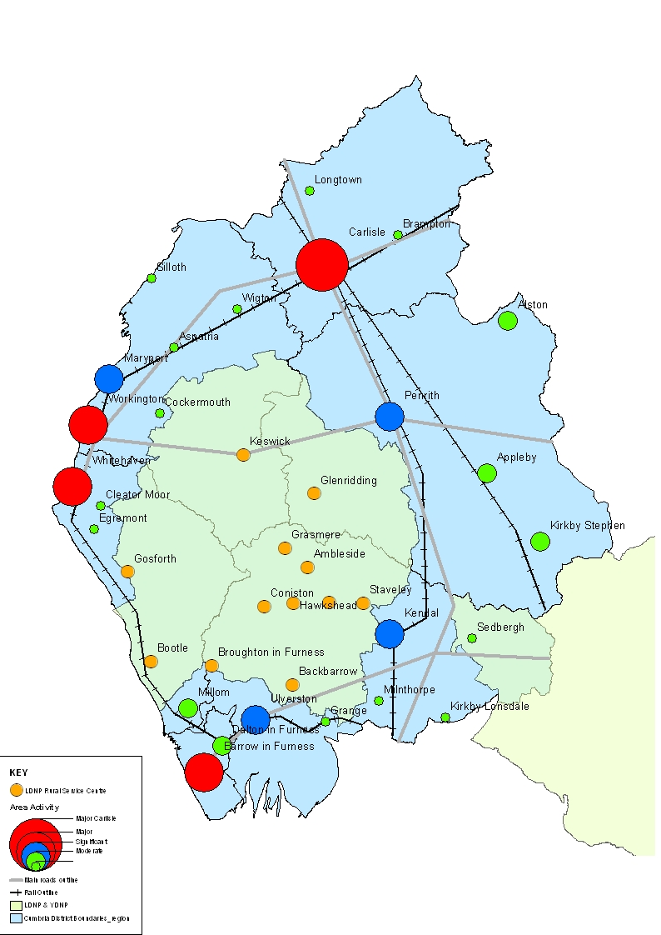
The spatial context of Cumbria: settlements and boundaries

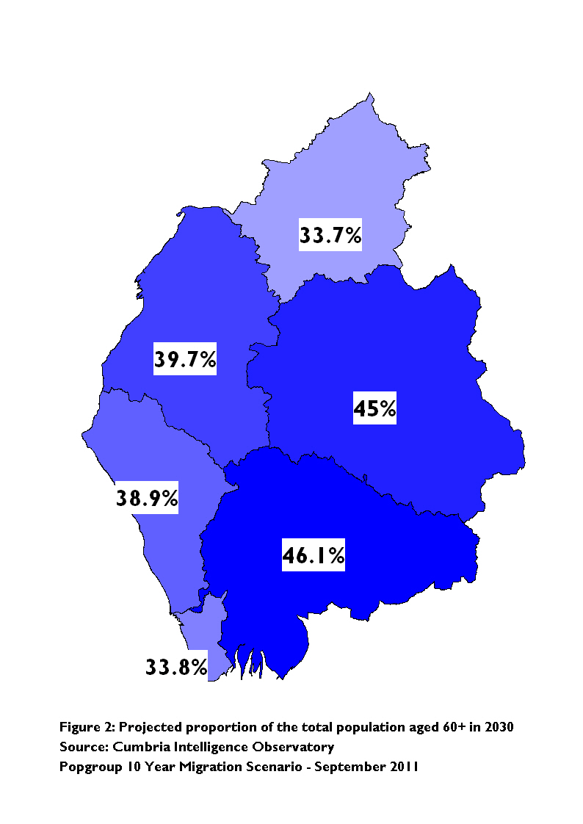
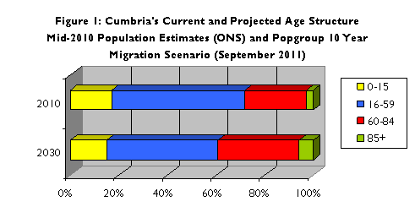
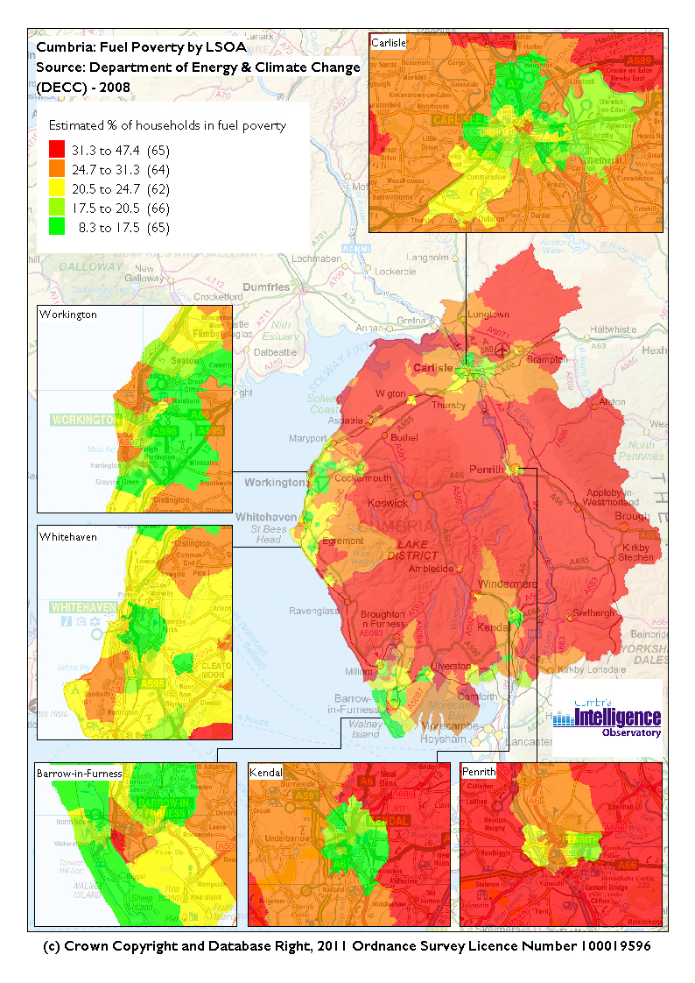
Cumbria: A strategic overview
Vulnerable People
Fuel poverty
Cumbria suffers disproportionately from fuel poverty when compared nationally. Across Cumbria an estimated 24.1% of households are in fuel poverty (spending more than 10% of income on maintaining a satisfactory heating regime); above the national average of 15.6% and the regional average of 18.1%. Eden has the highest proportion of fuel poor households in England at 34.8%. Allerdale is 13th at 25.5%, followed by South Lakeland at 14th with 24.6% of households (DECC, 2008).
Figure 3: Percentage of households in fuel poverty
By 2030 it’s projected that there will be a 41.7% increase in the number of residents aged 60+ and a 122.2% increase in the number of residents aged 85+. Inversely, the projections also suggest that, in the above timeframe, the number of younger residents, aged under 15, will decrease by 11%, while the number aged 16-59 will decrease by 15.3%. This would mean that in 2030 nearly 40% of the population would be aged 60+; compared to just under 30% in 2010. While national projections forecast a similar increase in older adults, they do not predict the same decrease in young people; in fact, national projections suggest numbers of young people will increase. Figure 2 presents the projected percentage of residents aged 60+ for 2030.
Life expectancy varies enormously across the wards in Cumbria; the best being 91.3 years in Greystoke, Eden district and the worst 71.8 years in Moss Bay, Allerdale district; giving a gap of 19.5 years. The national average is 78.3 years (Cumbria Intelligence Observatory, 2009).

At 679,715 hectares, Cumbria is England’s second largest county. With a population of 494,400 and at a density of 0.7 people per hectare, it is the third sparsest county nationally. 61.9% of wards in Cumbria are classified as rural, and over half of the population live in rural communities. There is a lack of ethnic diversity in Cumbria, with only 4.9% of the total population being of black or minority ethnic, compared to the national average of 16.7%. The median household income is £26,004; below the national average of £28, 989, and there are pockets of rural and urban deprivation. Cumbria has a two tier local Government system involving a county council, six local district councils and two national parks.
Demographic Profile
The population of Cumbria is projected to age dramatically over the next 20 years. Figure 1 presents the current and projected age profile of Cumbria’s population; based on the ’10 year migration scenario’ produced in September 2011 using Popgroup¹ modelling.

Homelessness
In 2009-10, 511 households were accepted as homeless with a duty owed to them across all districts; an average of 5.62 per 1000 households (Cumbria Homelessness Audit (Draft), 2010).

Deprivation
In terms of overall deprivation (2010) Cumbria is ranked 85th nationally (out of 149, where 1 is the most deprived). Barrow in Furness is the most deprived district; ranked 32nd out of 326 where 1 is the most deprived; this is within the 10% most deprived nationally.
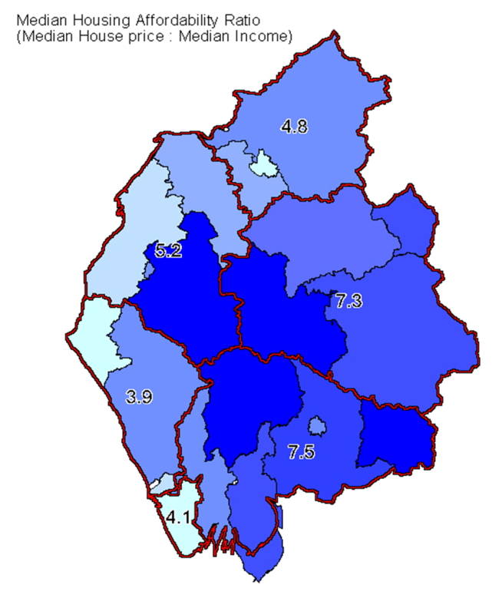
Figure 5: Annualised dwelling requirement
 | Range of average annualised dwelling requirements 2009-24
Allerdale | 197- 536
Barrow | 148- 225
Carlisle | 464- 693
Copeland | 151- 208
Eden | 231- 420
South Lakeland | 327- 694
Total | 1518-2777
Figure 4: Affordability ratio by Housing Market Area

Copeland is ranked 78th, Carlisle 109th, Allerdale 111th, Eden 211thand South Lakeland 242^{nd.} 22.1 % of children in Barrow-in-Furness are living in poverty; this is well above the average across Cumbria of 15.6%, and above the national average of 21.6% (HMRC (2008) National Indicator 116: The Proportion of children in poverty).
Affordability
The median house price in Cumbria is 5.5 times the median income. There are areas, specifically in the Lake District National Park, where the median house price is up to 11.7 times the median household income.
The median house price in Cumbria is £143,869, but there are disparities across the county: in Barrow-in-Furness it is £93,384 compared to £210, 977 in South Lakeland (CACI, Cumbria Intelligence Observatory, 2011).
Housing delivery
Historic Completions
Over the period 2006-11, 1449 new affordable homes have been completed across Cumbria.
The effect of the economic climate in recent years has had the consequence of reduced housing delivery across Cumbria, with a low of 993 new houses being delivered in 2008/2009. It should be recognised that away from the current economic climate, Cumbria has historically delivered significantly higher levels of housing with 1,858 new homes being completed in 2002/2003 and as many as 2,026 being delivered in 1992/1993 (Cumbria County Council, 2011).
Housing Requirements
Affordable Housing Need
Housing Needs Surveys calculate a projected need for 1792 affordable homes per annum: Allerdale: 245, Barrow: 20, Carlisle: 222, Copeland: 168, Eden: 227, South Lakeland: 640 (District Housing Need Surveys).
Overall dwelling requirements
Based on the POPGROUP model¹ using the latest 10 Year Migration Scenario and Labour Force Led Economic Forecasts prepared in June 2011, there’s a potential future annual dwelling requirement for construction of between 1,518 to 2,777 new homes across Cumbrian districts for the period 2009 to 2024. For the detailed breakdown for each District see figure 5.

¹POPGROUP is a modelling tool run by the Cumbria Intelligence Observatory, and commissioned through the Research & Information Expert Task Group. In line with the latest Government Guidance, it is used to produce a series of District level population and housing forecasts that may be delivered in differing population, housing and economic scenarios. The Model is able to link natural household growth through local data on in- and out-migration, births and deaths and expected economic growth.

Empty Properties
In Cumbria there are a total of 5001 properties that have been unoccupied and unfurnished for over 6 months. These comprise:
Allerdale: 854
Barrow in Furness: 1029
Carlisle: 754
Copeland: 820
Eden: 401
South Lakeland: 1143
(District Council Tax records, April 2011)

The Local Context

The Economy
In terms of economic activity there is a mixed picture across the districts: whilst levels of unemployment are relatively low, these figures mask significant variations in worklessness. Levels of educational achievement are below average at secondary level and there are marked variations in the qualification levels of the working population. The levels of earnings show considerable variation between districts that generally reflect variations in employment structure with lower average earnings in districts with a high proportion of employment in the service sector and rural economy, whereas full time earnings are above average in those areas dependent upon production industries. In the early 2000s, Cumbria’s economic performance lagged behind other areas but recent data suggests some improvement which has been experienced in both the east and the west. The number of businesses in Cumbria has increased significantly since the early 2000s and although rates of new firm formation are generally lower than the national average, medium term firm survival rates are relatively good.

Demographics
The demographic trend for Cumbria is towards an ageing population. The aim within Cumbria is to move towards enabling people to have more independence and options which will enable them to stay in their own homes. We need to work together to develop approaches/solutions to meet both current and projected need, which offer elderly people a range of options, enable them to stay in their own homes (if that is what they choose) and maintain their independence for longer.

At the same time that the proportion of elderly residents is increasing, projections suggest that the number of younger residents (aged under 15) will decrease by 11%, while the number aged 16-59 will decrease by 15.3%. This would mean that in 2030 nearly 40% of the population would be aged 60+, compared to just under 30% in 2010. While national projections forecast a similar increase in older adults, they do not predict the same decrease in young people instead national projections suggest numbers of young people will increase.

Barrow-in-Furness, Copeland and Allerdale
Barrow-in-Furness, Copeland and Allerdale districts contain urban centres, some of which have suffered long-term social and economic problems including high levels of worklessness. These largely result from an overdependence on the declining manufacturing sector and their relative remoteness from regional/national markets. Significant employment in these areas is dependent on a small number of key employers such as Sellafield Ltd or BAE Systems.
These areas are also home to Britain's Energy Coast where the focus is on becoming a major generator and centre of excellence in low carbon and renewable energy. A new programme of activity is being prepared for the area utilising socio-economic funding from the Nuclear Decommissioning Authority and Nuclear Management Partners, the company responsible for managing the Sellafield site.
These urban areas on the west coast are characterised by areas of housing market failure and/or areas of poor quality environment. This has given rise to a range of key issues to address including:
- The need to address housing market failure.
- The need for improving housing stock and a broadened housing offer through new supply to meet needs, including affordable and executive housing and others associated with the redevelopment of key sites.
- HCA investment in the West Cumbria Housing Market Renewal Pathfinder ended in March 2011 removing the funding for stock refurbishment, clearance and replacement, however there is still evidenced need for this type of activity.
- Delivery of economic growth focused on existing areas of strength in renewable and nuclear industries and new ones like education and tourism.
- Regeneration and measures to address problems associated with concentrations of deprivation and worklessness.
- It is expected that there will be a need for temporary short-term accommodation for significant numbers of construction workers because of nuclear industry new build.

Issues of affordability are also present in areas of West Cumbria. Based on parish surveys, Allerdale District requires 1200 affordable homes over the next 5 years. The 2010/11 Strategic Housing Market Assessment in Copeland demonstrates a need for 840 new affordable homes to 2015 (or 168 annually). These figures include a rural affordable housing need dispersed across Copeland district (including but not solely focussed on the National Park area where 75 new homes are needed over the same period).

Copeland
In Copeland, communities are linked by common housing markets, family connections and travel to work patterns, which combine to make locality-based service delivery a priority. The area is one of the most remote and difficult to access in England however this is mitigated by some of the most stunning scenery - the Lake District National Park comprises two thirds of the District together with 50 miles of beautiful coastline.
The main source of employment at Sellafield has a decommissioning plan resulting in a potential major loss of existing local employment. In 2010 almost one third of the District’s workforce depended directly or indirectly on this facility. As part of Britain’s Energy Coast Vision, the Council and its partners are determined to convert this threat into an opportunity by enabling a new-build nuclear facility together with associated reprocessing, research and educational facilities, as well as diversifying into renewable energy generation.
Copeland’s housing markets are vulnerable to decline, exacerbated by demographic trends and a lack of economic diversification and growth. There remains a strategic need for housing renewal.

Eden and South Lakeland
Eden and South Lakeland districts have both excellent strategic transport links and outstanding natural beauty; this has meant that there is considerable demand for housing from in-migration of either long distance commuters, people retiring or from holiday and second home buyers. Together these lead to increased competition for housing resulting in issues of affordability specifically for local people on lower wages. While this area has generally high levels of employment, there are issues of low paid and part time work, especially in rural areas. Key issues here include:
- The shortage of housing that is affordable to local people.
- The need for more well paid employment opportunities aided by sustainable employment sites and town centre initiatives.
- Diversification of the rural economy.
- Sustainability of rural villages and market towns.
- Meeting the needs of an ageing population for suitable housing with appropriate levels of support in accessible locations.
- Fuel poverty.
- Providing a range of housing and economic opportunities for young people to retain/attract them to the area.

The National Parks
The Lake District National Park is a landscape of exceptional beauty; it covers an area of 2,292km² and encompasses parts of Eden, South Lakeland, Copeland and Allerdale districts. The continuing high cost of homes that are inflated by high levels of second home ownership and the outstanding environment that attracts people to the area who are able to afford the high prices puts immense pressure on the existing housing stock. This makes it extremely difficult for people relying on local wages to compete for housing in an open market. As a result in the National Parks, planning policies apply which restrict new housing to those with a local connection and those taking up employment in the area.

The Vision for the National Park is that, “The Lake District National Park will be an inspirational example of sustainable development in action. A place where its prosperous economy, world class visitor experience and vibrant communities all come together to sustain the spectacular landscape, its wildlife and culture.” The Business Plan for the Lake District National Park 2011 – 2014 has a number of core themes including “Contributing to a Prosperous Economy” and “Contributing to Vibrant Communities”. Within these themes, priorities specific to housing include:
- Appropriate economic growth is enabled to support National Park communities.
- Increased availability of land for affordable and local needs housing.

The north western tip of the Yorkshire Dales National Park takes in part of the South Lakeland district. The mission of the National Park is to “promote a sustainable and dynamic rural economy, paying special attention to the needs of local communities within the National Park”. The vision of the Yorkshire Dales National Park Housing Development Plan 2011-25 includes to:
- Improve the supply of housing, particularly affordable housing, to benefit social and economic vibrancy of the local community.
- Making the best use of land and locations that have benefits to local services, work places, social networks and public transport.

Carlisle
Carlisle is the largest service centre for Cumbria and South West Scotland, and is a key focal point for growth. Their vision is that in 25 years time, the City should be described as ‘Cumbria’s dynamic and successful University City, creating growth opportunities in a sustainable environment with skilled people and international connections in a stunning location”.

Ultimately, Carlisle requires sustainable growth to enable more jobs and services (including educational infrastructure and homes) in both the urban and rural areas. In recognition of this need, and the critical relationship between economic growth and good quality and suitable housing, Carlisle achieved Growth Point status in 2009 and aims to retain this.
Key issues for the continued growth of Carlisle include:
- New large scale housing development including affordable housing and associated social infrastructure to meet the needs of urban and rural communities;
- Further housing renewal schemes are to be continued in weak market areas; and
- Delivery of strategic employment sites across the city and development of the city’s higher education function.
The Future: where do we want to be and how will we get there?

Where do we want to be?

Based on evidence and local expertise we have identified three key themes where we want to make progress over the course of this strategy; these do not reflect the entirety of the issues faced by Cumbrian communities but are the key areas where Cumbria Housing Executive Group feel we can add value and make a difference.

Key Theme 1: Housing Growth, Affordability and Community Sustainability
We want housing which supports a growing economy and sustainable communities:
- Where the need for affordable and market housing to support economic opportunities identified by the LEP, are delivered.
- Where housing needed to develop the rural economy is delivered.
- Where funding opportunities around growth are maximised.
- Where housing supports improvements to health and well-being.
- Where collective procurement will achieve cost effective delivery of new public sector housing.
- Where the development of new housing is underpinned by improvements to the physical infrastructure, and in adherence to related strategies.
Because:
- Levels of worklessness for Cumbria are below the national average; however there are areas where Job Seekers Allowance claimant rates are up to 8.7% of the population compared to a national average of 3.8%.
- 29 statistical areas (Lower Super Output Areas – LSOAs) in Cumbria, 9% are within the 10% most deprived nationally (based on the Index of Multiple Deprivation).
- The median household income in Cumbria is £26,004; below the national average of £28,989.
- 61.9% of the wards that make up Cumbria are classified by DEFRA as Rural.
- It is projected there will be a 44.8% increase across Cumbria in the population of residents aged 60+, and a 120.5% increase in residents aged 85+.

We want housing that is affordable:
- Where people in urban and rural communities are able to access housing appropriate to their needs and within their means, particularly social rented accommodation in rural areas.
- Where the impacts of welfare and housing benefit reform, financial inclusion and fuel poverty are addressed.
- Within which resources such as land, public and private finance, New Homes Bonus and planning gain are focused on meeting housing needs.
Because:
- Parish wide housing needs surveys within the Lake District National Park indicate 80% of those identified as being in housing need require social rented housing and 20% require intermediate tenure.
- The median house price in Cumbria is 5.5 times the median household income. There are areas, specifically in the National Parks, where the median house price is between 11.7 (Lake District National Park) and 12.8 (Yorkshire Dales National Park) times the median income.
- Based on 2009-10 levels of delivery, Cumbria has provisionally been allocated £4,475,975 of New Homes Bonus over the next 6 years.

Key Theme 2: Vulnerable People, Supporting Independence
We want vulnerable people to:
- Be empowered to live independently with the ability to purchase the care/support needed to maintain their tenancy and fully engage in their local community, either through access to personal budgets, direct payments and/or Supporting People provision regardless of gender, ethnicity, disability, age, sexuality, or faith.
- Have access to extra care housing as and when appropriate.
- Have access to energy saving advice and/or products.
- Have access to disability adaptations grants i.e. Disability Facilities Grant programme.
- Have good access to banking and credit.
- Have access to paid employment or a supported employment programme moving people towards the world of work.
- Maximise their life chances as young adults by having access to accommodation that supports their employment, education and training, enabling them to contribute to safer and stronger communities.
Because
- Provision is needed for excluded households such as Gypsies and Travellers. The county-wide need for 89 pitches can be best met through a joint approach from all districts.
- Analysis undertaken in 2009 estimated there will be demand for at least 1,850 extra care housing properties across Cumbria by 2019.
- Based on demographic trends and current service patterns, there will be a significantly increased need for care support in the future.
- On average 20.6% of residents in Cumbria are suffering from fuel poverty (households spends more than 10% of income on maintaining a suitable heating regime), above the national average of 13%.
- 23.6% of over 85’s suffer from dementia.
- 7 out of 10 of homeless people experience one or more mental health problems.
- As of September 2011, there are 74 looked-after young people across Cumbria aged 16 or over who will soon be leaving care. Last year 54, 16 or 17 year olds in Cumbria left care.
- Over 140 young people aged 16 or 17 came to the attention of the agencies as “homeless” in the year to June 2011.

Key Theme 3: Housing Market Renewal: Using Stock More Effectively
We want to maximise the potential of the existing (private and public sector) housing stock so that:
- There is continued support for housing market renewal including an increase in the choice and quality of housing stock and the regeneration of our oldest and poorest housing.
- Significant progress is made in adapting homes to meet special needs, bringing empty and under-occupied homes into beneficial use, eliminating sub-standard housing, improving energy efficiency and matching the stock to the needs of tenants through an expanded choice based letting scheme.
- Tenancy strategies seek to ensure that social housing assists in meeting current and future housing need, maintains stable communities and that best use of stock eliminates overcrowding and under occupancy.
- Mechanisms are established to ensure that second homes/holiday homes do not form more than 20% of the local housing market.
Because
- Despite the removal of Housing Market Renewal funding, there is still an evidenced need for stock refurbishment, clearance and replacement in certain areas.
- There are approximately 5000 properties across Cumbrian districts that have been empty for over 6 months.
- On average 48% of private sector stock across Cumbrian districts is non-decent; above the national average of 36%.
- Councils will be able to utilise the private rented sector to discharge their homeless duty. (Historically, homelessness is a ‘lagging indicator’ following an economic downturn – meaning that it can be expected to rise for some years, independently of policy impacts.)
- 33% of parishes in the Lake District National Park have more than 20% of their housing stock used as either a second home or holiday home and studies suggest that when the proportion of holiday houses reach a particular level, this affects the sustainability of any settlement and its community.

Action Plans
The three key themes articulated above form the basis of actions plans which are appended. These action plans were developed collaboratively by members of the Cumbria Housing Officer Group and the expert groups. There is an action plan relating to each key theme plus two supporting action plans which relate to Research and Information; and Influencing local and national agendas. Using the evidence base we have, to influence key agendas, to provide a Cumbrian perspective on debates at a local and national level is a priority for this strategy.

These action plans will be delivered through expert groups, specific to each key theme. Membership of the expert groups draws on specialist knowledge and expertise from across the private/public/third sector. The expert groups have a generic purpose to:
- Deliver the work plans developed to support the Cumbria Housing Strategy and Investment Plan 2011-2015.
- Identify barriers and challenges to delivering the action plans and to use their shared expertise to overcome these.
- Share good practice.
- Report progress and any blockages to the officer group.

This strategy is only current at the time at which it was written; the context in which we operate is undergoing significant economic and legislative changes and effectively this provides a snapshot of where we are. In recognition of this our action plans are intentionally short-term and focus on the next 12-24 months. The action plans will be revisited in 18 months time to refresh and refocus.

Our Approach
In working to address these issues we will:
- Work collaboratively and innovatively with communities and/or through local authorities to draw down resources across Cumbria to maximise access to funding available such as that for Community Land Trusts (CLTs) or Empty Properties.
- Work in partnership with the Homes and Communities Agency to deliver more housing.
- Work closely with the private sector to maximise private sector investment and delivery.
- Be opportunistic in our approach to solving problems.
- Seek to learn from others, within the partnership and the wider housing world, and customise approaches that have worked elsewhere to make them work for us.
- Be flexible in our approach, recognising actions need to be locally appropriate.
- Work together to combine our expertise and to ensure we add value.
- Speak with a single voice to demonstrate the uniqueness and diversity of Cumbrian district communities.
- Promote our successes and our ability to deliver.
- Influence at a local and national level to the benefit of all Cumbrian communities.
- Continue our evidence-based approach.

How will we get there?
This work is driven by the Cumbria Housing Executive Group (CHEG), supported by the Cumbria Housing Officers Group (CHOG). The purpose of the Cumbria Housing Executive is to:
- Make recommendations which shape housing in Cumbria.
- Support the development of policy and strategy.
- Direct work groups to deliver specific projects.
- Influence and give a Cumbrian voice to the Northern Housing Consortium, North West Housing Forum and/or other local, regional and national consultation.
- Promote joint initiatives across the districts which maximise resources and make most efficient use of them.
- Monitor the effectiveness of organisations’ service delivery in Cumbria and work together for continuous improvement.

The purpose of the Officer Group is to:
- Provide an operational focus to strategic issues.
- Identify areas for joint working or those with potential for added value.
- Inform the work of Executive Group.
- Oversee the action plans of specific expert groups.

This group oversees policy and strategy development and directs work/”expert” groups to deliver specific projects. Representatives attending this group have clear mandates to work together to realise the vision. This group has links into a range of more specialist housing groups and organisations which are active across the districts and county and therefore has the ability to draw on this network to provide an expert, Cumbria-wide overview. This extensive network covers:

- Cumbria Housing Forum;
- Cumbria Health and Wellbeing Board;
- Supporting People Commissioning Body;
- Cumbria Registered Provider Forum;
- National Housing Federation;
- Cumbria House Builders Group;
- Homes and Communities Agency;
- Northern Housing Consortium;
- Housing in the North All Party Parliamentary Group;
- North West Housing Forum;
- Homes and Communities Agency;
- Cumbria Members of Parliament;
- Cumbria Rural Housing Trust;
- Cumbria Association of Local Councils;
- Cumbria Housing Group Expert Groups.

Appendix 1: Source list- The impact of housing on…

…Economic Growth
- National Housing federation: ‘Home truths 2010: North West’
- The Guardian, September 2011: http://www.guardian.co.uk/society/joepublic/2011/sep/14/national-planning-policy-framework-confusion-housing1
- Business Register and Employment Survey, 2009.
- Shelter publication: ‘Chance of a lifetime - the impact of bad housing on children's lives’, 2006.
- Cumbria Business Survey, 2010.
- Cumbria Intelligence Observatory Popgroup modelling, September 2011; and Cumbria Place Survey, 2008/09.

…Balanced sustainable communities
- Cumbria place Survey, 2008/09.
- Shelter publication: ‘Chance of a lifetime - the impact of bad housing on children's lives’, 2006.
- Cumbria place Survey, 2008/09.
- Cumbria Rural Housing Trust publication: ‘Effective ways to sustain our rural communities’, 2003.
- Cumbria County Council, CACI data, June 2011.

…Health and well being
- Chartered Institute of Housing: ‘Housing Health and care’, 2009.
- Cumbria Homelessness Audit, 2010.
- Shelter publication: ‘Chance of a lifetime - the impact of bad housing on children's lives’, 2006.
- Department of Energy and Climate Change, 2008.
- Chartered Institute of Housing: ‘Housing Health and care’, 2009.

Reference Documents
Cumbria Homelessness Strategy
Local Investment Plan
Planning4Care Report: Projected need for long-term residential care services for older people in Cumbria, 2009.
Joint Strategic Needs Assessment
Cumbria Local Economic Assessment

Appendix 2: Development Priorities

Agreed development priorities identified in the Cumbria Sustainable Community Strategy (2008-2028) stress the importance of ensuring development is distributed appropriately and sustainably across Cumbria. Major development will be focused on the regeneration areas of Barrow, Workington and Whitehaven and on the growth of Carlisle. The spatial policy framework recommends there should be significant development in Kendal, Penrith, Ulverston and Maryport, but here greater consideration needs to be given to the scale and the capacity for development. Elsewhere moderate development will take place in the Key Service Centres of: Dalton-in-Furness; Aspatria; Cockermouth; Brampton; Longtown; Wigton; Cleator Moor; Egremont; Millom; Silloth; Alston; Appleby; Grange-over-Sands; Kirkby Lonsdale; Kirkby Stephen; Milnthorpe and Sedbergh.

In sparse rural areas, the character of individual settlements will be protected, and development will strengthen the economy and services. Small-scale development is to take place in Local Service Centres and other locations (as identified in Local Development Frameworks) to help sustain local services, meet local needs, including the centres’ rural hinterlands and to support rural businesses. New small-scale balanced housing development (the majority of which should be affordable) will be encouraged where it supports the sustainability of the Local Service Centre. In the open countryside, development will only take place in exceptional circumstances. These circumstances can include an essential requirement for a rural location which cannot be accommodated elsewhere, and development which is fundamental to delivering positive transformational change to the local economy.
The area comprising the 2 National Parks is not encompassed within the Spatial Strategy. The adopted LDNPA Core Strategy identifies 13 Rural Service Centres and other communities where the focus of new development will take place to meet locally generated needs, and includes Ambleside, Keswick, and Windermere/ Bowness.

Strengths | Weaknesses
- Track record of working collaboratively to develop an evidence-based approach to housing.  - Evidencing and communicating the case successfully to secure funding for Cumbria.  - Track record of delivery.  - County-wide structures established.  - Level of expertise within county.  - Past strategy and willingness to work in partnership.  - Close working relationship between partners/districts which means a good awareness of others’ issues (which leads to...)  - Track record of working together to deliver service improvements e.g. Disabled Facilities Grant, Choice Based Lettings.  - The ability to work together effectively to prioritise housing issues.  - External perception that Cumbria speaks with a single voice  - Diversity of area. | - Lack of funding for affordable housing.  - Lack of access to funding to meet current and projected need for supported housing.  - 6 housing authorities with limited capacity to work collaboratively across districts.  - Lack of focus on what partners have in common.  - Income to house price ratio in certain districts/parts of districts.  - High house prices combined with issues of second homes.  - NIMBYism manifested by a resistance to change.  - Low incomes.  - Political/geographical/demographic diversity.  - Perception that localism = every district on their own, “Cumbria” is no longer relevant.  - Poor condition of private stock in certain areas.  - Lack of diversity of stock in certain districts.  - Ability of districts to engage jointly and effectively to influence county.  - The lack of engagement generally with private sector landlords.
Opportunities | Threats
- Cumbria Improvements & Efficiencies Partnership funded posts able to drive new strategic approach to housing delivery.  - Work in partnership, share skills & best practice to deliver in the context of scarce resources and achieve efficiencies.  - Influence in relation to the Big Society/Rural Vanguard area.  - Influence new housing to sustain communities.  - Influence communities to accept and prioritise development.  - Links to Local Enterprise Partnership/Health & Wellbeing Board to embed housing within new structures.  - Deliver market and affordable housing once Local Development Framework adopted.  - Develop the single Cumbria voice to promote the county & increase profile/impact.  - Identify innovative/flexible models of funding to deliver affordable housing.  - Explore innovative models for private sector funding of housing.  - Work together to develop solutions to common issues.  - Adopt a proactive approach to working within the new legislative/policy framework to trail-blaze solutions.  - Diversity: draw on benefits and accept differences.  - Focus limited capacity on tackling achievable actions that have a clear impact/benefit.  - Expand the remit of the Choice Based Lettings scheme to include the private sector.  - Promote our message/issues with a consistent voice into other forums e.g. Housing in the North All Party Parliamentary Group.  - Deliver action plans that add value to individual districts/partners. | - Cumbria Improvements & Efficiencies Partnership funded posts that create strategic capacity across the county are fixed term and due to finish in March 2012.  - Lack of co-ordination of the strategy results in a fragmented approach and delivery with a greatly reduced impact.  - Lack of money to deliver social rented housing and regeneration of private stock.  - Effects of the economic downturn and the retraction of bank lending on general capacity to deliver housing.  - Affordable rent is not going to be affordable in certain areas of Cumbria.  - The impact of the affordable rent regime on development capability.  - Tight planning controls in National Park mean funding the development of affordable housing will be challenging.  - Maintaining existing private rented stock.  - Diversity of area: urban and rural.  - No focus on regional/sub-regional any more.  - Lack of engagement in collaborative/shared working.  - Protectionism brought about by localism agenda/funding cuts.  - Ability of Disabled Facilities Grant to meet current demand and projected increased demand.  - Focus on differences rather than commonality could undermine the partnership approach.  - Slow adoption of Local Development Framework.  - Demographic projections show an ageing population and loss of the working age.

Appendix 3: SWOT Analysis

Appendix 4: Progress of the Local Development Framework by Local Authorities in Cumbria
The dates provided are an estimate as of October 2010.
 | Core Strategy | Other Development Plan Documents (DPD)
Allerdale Borough Council | Reg 25 – January/February 2012  Reg 28 – September 2012 | General Development Control Policies, Site Specific Allocations DPD and Proposals Map  - Reg 25 – June 2012  - Reg 28 – Autumn/Winter 2012
Barrow Borough Council | None confirmed | None confirmed
Carlisle City Council | Reg 25 – Spring 2012  Reg 28 – early 2013 | Allocations of Land DPD to follow Core Strategy  SHLAA and Employment Land Review  - Informal consultation- January 2011.
Copeland Borough Council | Reg 28 – March 2012 | Development Management Policies  - March 2012  Site Specific Allocations and Policies DPD  - Reg 25: Autumn 2012
Cumbria County Council | Adopted 23rd April 2009. | Site Allocations Policies DPD and Proposals Map adopted 20 January 2011
Eden District Council | Adopted 31st March 2010 | Housing Site Allocations DPD  - Reg 25 – Winter 2012
South Lakeland District Council | Adopted 20th October 2010 | Land Allocations DPD  - Reg 25- August 2011  - Reg 28-Winter 2012
Lake District National Park | Adopted 20th October 2010 | Land Allocations DPD  - Reg 25-November 2011
Reg 25: Formal consultation. The LPA must notify specific bodies of the subject of the DPD and invite representations. In preparing the DPD, the LPA must take into account any representations made.
Reg 28: Period to receive representation on the DPD. This is not a consultation stage but it is when formal representation on the soundness of the DPD can be made. These representations will be taken into account at the formal examination.

The Housing Forum is a wider networking group of housing, house builders, health, planning, economic development and community groups.
Appendix 3 contains the SWOT analysis undertaken to inform the identification of the key themes.
Cumbria Rural Housing Trust: An Effective Way to Sustain our Rural Communities Part 1: The Effects of Affordable Housing in Rural Communities.
Leather, P 2011
Research published September 2011 by Policis consultancy, commissioned by Big Issue Invest and supported by the National Housing Federation.
The Local Development Frameworks (LDF) produced by the planning authorities give a comprehensive list of development and investment priorities in each local area. See Appendix 4 for an overview of progress by Local Authority.
See Appendix 2 for more detail of development priorities across the districts.
Cumbria Local Economic Assessment, Cumbria Summary, November 2010, University of Cumbria Centre for Regional Economic Development and Cumbria Intelligence Observatory
Lake District National Park Business Plan 2011 – 2014.
Appendix 3 contains the SWOT analysis undertaken to inform the identification of the key themes.
The Local Development Frameworks (LDF) produced by the planning authorities give a comprehensive list of development and investment priorities in each local area. See Appendix 4 for an overview of progress by Local Authority.
Strategies relating to physical infrastructure: Transport- Local Transport Plan 3 (LTP3); Education- developer contributions; Adult Social Care provision- Cumbria County Council Extra Care Strategy and Old Peoples Accommodation Assessment; Health- Joint Strategic Needs Assessment.
Planning4Care Report: Projected need for long-term residential care services for older people in Cumbria, 2009.
Planning4Care Report: Projected need for long-term residential care services for older people in Cumbria, 2009.
Cumbria Rural Housing Trust: An Effective Way to Sustain our Rural Communities Part 1: The Effects of Affordable Housing in Rural Communities.
Crisis, December 2010. Homelessness strategies across the districts will be due for review in 2013.
2001 census data.
See Appendix 5 for details.

