Barrow Borough Council
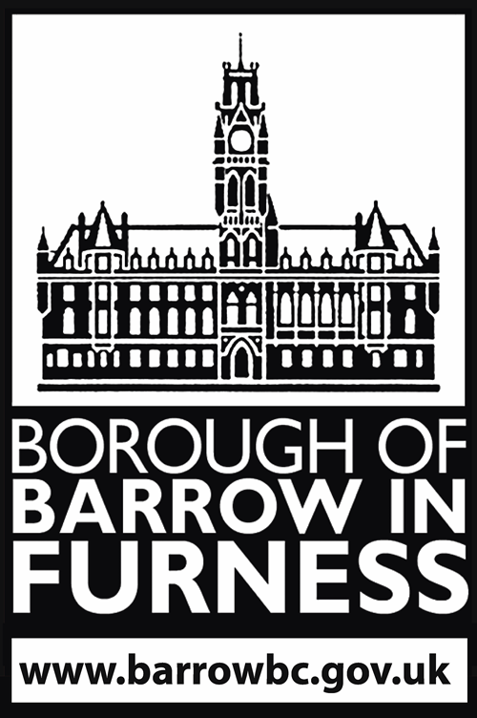
Event Notification Form

This Event Notification Form should be completed by event organisers who intend to hold a public event in the Barrow Borough Council.

The completed form, together with the Event Management Plan and Risk Assessment should be electronically submitted via commercial@barrowbc.gov.uk to Barrow Borough Council Safety Advisory Group at least 4 months prior to the event start date.

Event
Name of event:
Location / route of event: Attach a site plan if appropriate.
Landowner:
Date(s) |  | Start Time: |  | End Time:
Number of Participants: |  | Number of Spectators: |  | Number of Staff:
Event type and brief description

Age of target audience: |  | Family | Mature Adults >25 | Young Adults  18-25 | Vulnerable or ‘at risk’
Event History

Provide details of previous events including previous attendance numbers, safety issues, complaints.

Event Organiser details
Organisation:
Event Organiser Name:
Contact Telephone:
Contact Email:
Experience:

Running this event / similar or other events / qualifications / support team.

Event details
Additional details to be provided as an appendix where necessary
Has permission from the landowner been provided? YES/NO
Will alcohol be sold / provided at this event? YES/NO
Have you obtained the appropriate permission from Barrow Borough Council? YES/NO
Is the event providing regulated entertainment/music/singing/dancing? YES/NO
Have you applied for the appropriate permission from Barrow Borough Council? YES/NO
Is the event being publicly advertised? (If YES, how long before the event?) YES/NO
Is the event serving food/providing catering? YES/NO
If yes, provide brief description
Are you providing stewarding? YES/NO
Please provide details
Do you require a police attendance (this could be chargeable)? YES/NO
Are there any of the following attractions proposed:
- Temporary structures//tents/inflatables/bouncy castles YES/NO
- Special effects/pyrotechnics/fireworks/lasers YES/NO
- Fairground rides YES/NO
- Carnival/procession/parade YES/NO
- Bonfire/barbecue YES/NO
- Static display e.g. motor vehicles YES/NO
- Aircraft/hot air balloons/parachutists/balloon launch YES/NO
- Re-enactment groups YES/NO
- Market stalls YES/NO
- Live animals be present (including live animals given as prizes)? YES/NO
If yes, please provide additional details (wind testing confirmation required for structures)
Are there any of the following infrastructure required:
- Temporary structures/marquees/tents/staging/scaffolding structures YES/NO
- Power generator/power supply YES/NO
- Compressed gas e.g. LPG/helium YES/NO
- Crowd control barriers/fencing YES/NO
- Floodlighting
If yes, please provide additional details (wind testing confirmation required for structures)
Is there camping associated with the event? YES/NO
Please provide details
Is the event on part of the public highway? YES/NO
(event staff cannot legally control/direct traffic)
Is traffic management and signage required? YES/NO
Has a parking and local impact assessment been carried out? YES/NO
Entrances, exits, turnstiles and emergency exits.
Please provide details including capacity calculations and evacuation routes
Is there a designated emergency services access route / parking area
Please provide details YES/NO
What are the communications systems for emergencies (PMR/CB/Phone/Amateur, etc.)?
Details of setup (including contact details of Ofcom licence holder and User Service Provider -
Cumbria Raynet or other accredited licenced provider)
Has it been tested in location? YES/NO
Welfare arrangements for event staff, participants, and spectators.
Please provide details
Are you providing First Aid provision? (refer to HSE guidance) YES/NO
Please provide details
Do you have a lost child point / policy?
Please provide details YES/NO
Waste management arrangements (including disposal of human and other waste)? YES/NO
Please provide details
Have you undertaken a risk assessment for the event/location/route? YES/NO
(Please submit a copy)
Have you undertaken a fire risk assessment for the event/location/route? YES/NO
(Please submit a copy including a plan of fire safety provisions)
Crown Management and Anti-Terrorism Measures? YES/NO
Please provide details.
Will the event organiser oversee the event on the day? YES/NO
Please provide details if different from the event organiser.
Are you following a Governing Body’s/Association’s national guidelines? YES/NO
If so, which one?
Do you have public/product liability insurance cover in place for this event? YES/NO
(Please submit a copy)
Cancellation and contingency plans included in the overall management plan? YES/NO
Other safety measures/plans/considerations specific to the event in place.

Please provide details:

Please remember to attach the additional details or documentation as detailed in the notes above. Reference to the relevant section of the Event Management Plan (EMP) is adequate for this purpose.

Signed: Date:

